AWS CloudFormation Master Class v2 [2022]

Course Objectives:

* Learn CloudFormation and master all its concepts.
* Go through Hands On examples to practice what we learned.
* Learn how to use YAML to write the CloudFormation templates.
* Learn how to write your infrastructure as code(laC).
* Launch Several templates.
* Advanced concepts overview

Who is this course for?

* Developers who want to learn about AWS CloudFormation and how to write templates.
* Devops who want to learn how deploy and orchestrate CloudFormation templates.
* Solutions Architect who wants to understand the benefit of using CloudFormation to manage infrastructure and steer their team to use CloudFormation.

Prerequisites:

* Basic Knowledge of AWS is required.
* AWS IAM
* AWS S3
* AWS EC2, Security Groups, Autoscaling groups.
* AWS Lamba
* A Few others…
* Knowledge of JSON and/or YAML is preferred.
* Recent MacOS /Linux /Windows Machine
* Lots of desire to learn new exciting things!!

Lesson 2:

What is CloudFormation:

* CloudFormation is a declarative way of outlining your AWS Infrastructure, for any resource (most of them are supported).
* For Example, within a CloudFormation template, you say:
* I want a security Group.
* I want two EC2 Instance using this security Group.
* I want two Elastic Ips for these EC2 instances.
* I want an S3 Bucket.
* I want a load Balancer (ELB) in front of these EC2 Instance.
* Then CloudFormation creates those for you, in the right order, with the exact configuration that you specify.

CloudFormation Template Example:

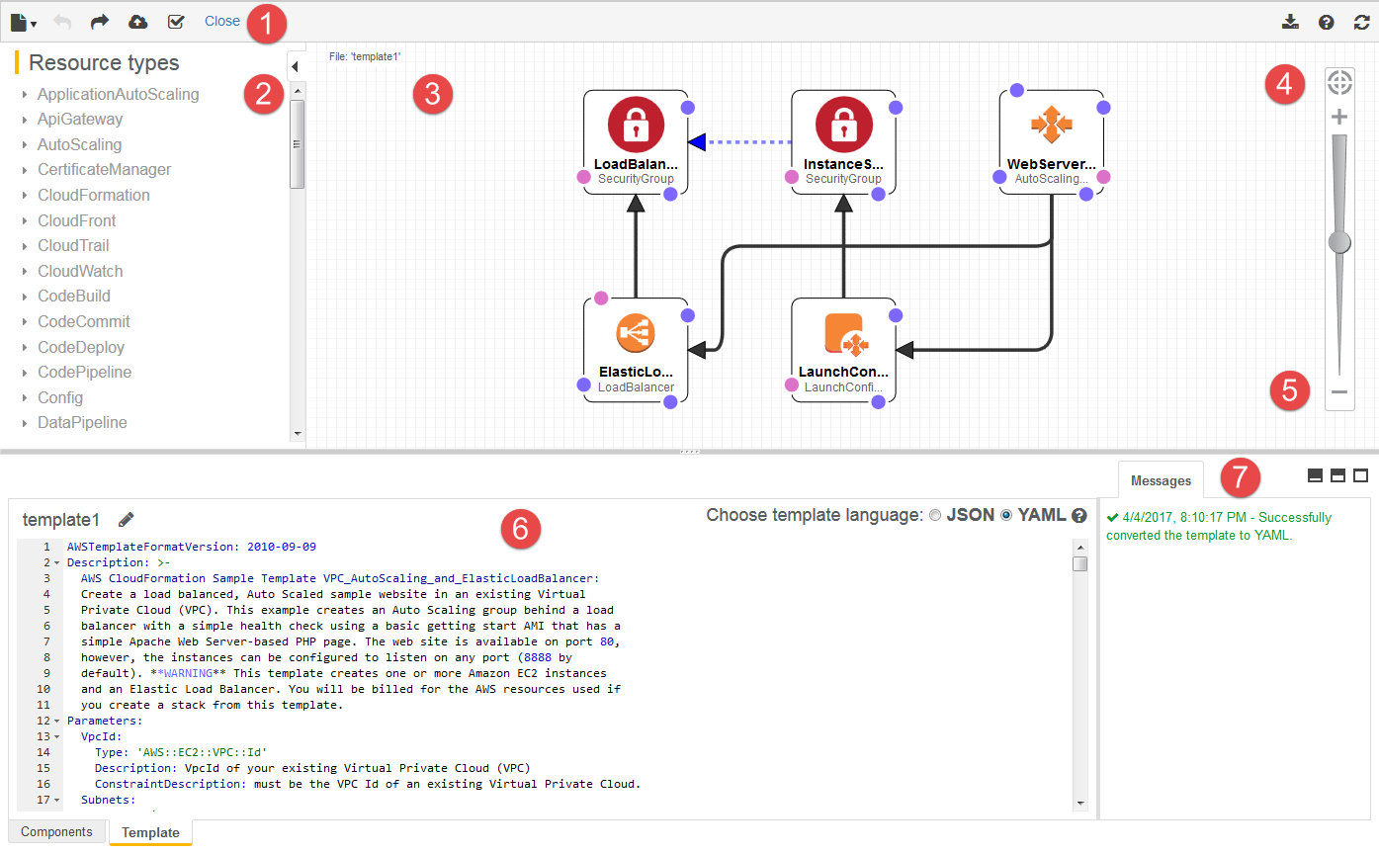

Benefits of AWS CloudFormation(l/2)

* Infrastructure as code :
* No resources are manually created, which is excellent for control.
* The code can be version controlled for example using Git.
* Changes to the infrastructure are reviewed through code.
* Cost:
* Each resource within the stack is tagged with an identifier so you can easily see how much a stack cost you.
* You can estimate the costs of your resource using the CloudFormation template.
* Savings strategy: In Dev, you could automation deletion of templates at 5PM And recreated at 8 AM, Safely.

Benefits of AWS CloudFormation (2/2)

* Productivity
* Ability to destroy and re-create an infrastructure on the cloud on the fly.
* Automated generation of Diagram for your templates!
* Declarative programming (no need to figure out ordering and orchestration).
* Separation of concern: Create many stacks for many apps, And many layers. EX:
* VPC stacks
* Networks stacks
* App Stacks
* Don’t re-invent the wheel.
* Leverage existing templated on the web!
* Leverage the documentation.

What this course won’t do?

* This course won’t go over every AWS Services.
* There are 200+ services,700+ Resource types so it’s impossible to cover them all.
* Instead, we’ll go over understanding how to write a CloudFormation template in the perfect way.
* Then you just pick up the documentation for your services and it will be as easy as 1..2..3!

Course Cost:

* AWS CloudFormation is free, but the resources it may create are not.
* Some resources are covered by the AWS Free Tier, and some are not.
* Overall, if you want to experiment after the class, budget around $10.
* Don’t forget to delete your CloudFormation stacks after the lectures!!

Quiz 1:

Question 1:

Using AWS CloudFormation is free, but you are charged for the resources it creates (e.g., EC2 Instances, Elastic Load Balancers, etc.).

And:True

Question 2:

Which AWS service helps you create your AWS Infrastructure resources in the right order you specify?

Ans:AWS Cloud Formation.

**Section -2: Code Download & Tools Setup:**

**Code Download**

Please follow the instructions at [**https://courses.datacumulus.com/downloads/aws-cloudformation-1b5**](https://courses.datacumulus.com/downloads/aws-cloudformation-1b5) to download the code.

**VSCode Setup**

**Tools used in the course**

Note: the setup is done in video form in the next lecture

VSCode: <https://code.visualstudio.com/>

With the cfn-lint extension: <https://github.com/aws-cloudformation/cfn-lint-visual-studio-code>

Install cfn-lint here: <https://github.com/aws-cloudformation/cfn-lint>

<https://www.techielass.com/install-cfn-lint-on-windows/>

wsl –install 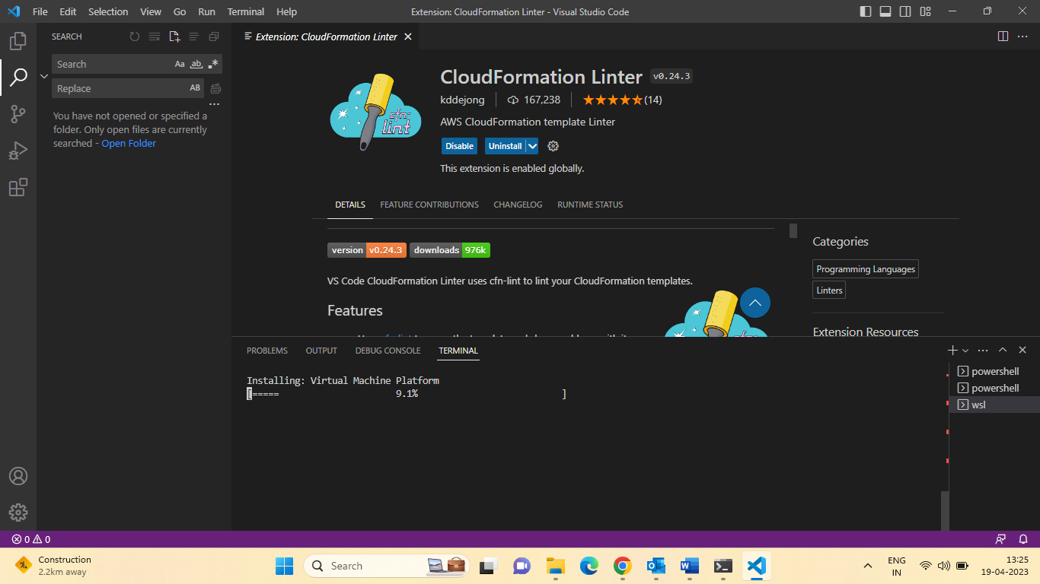

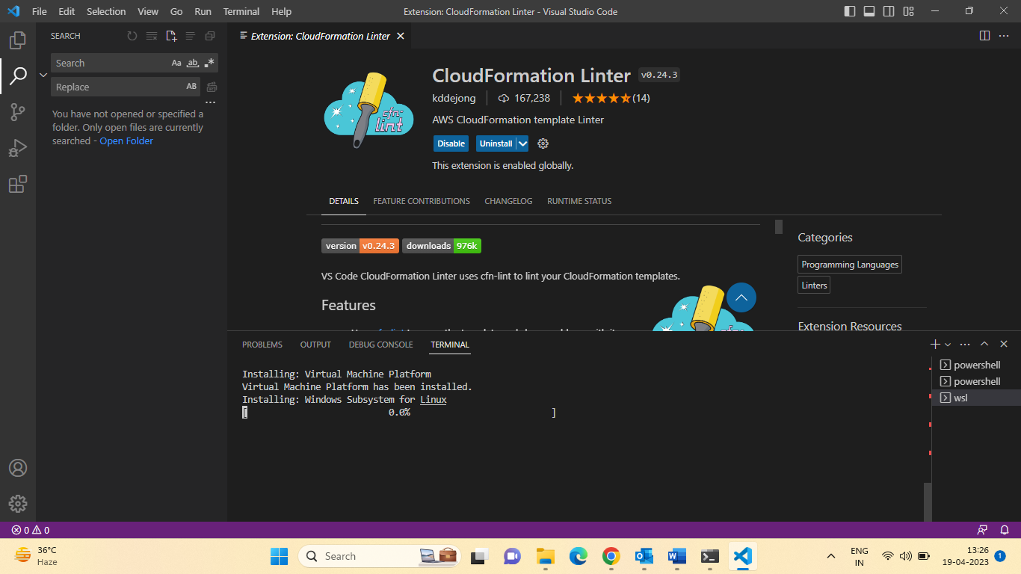

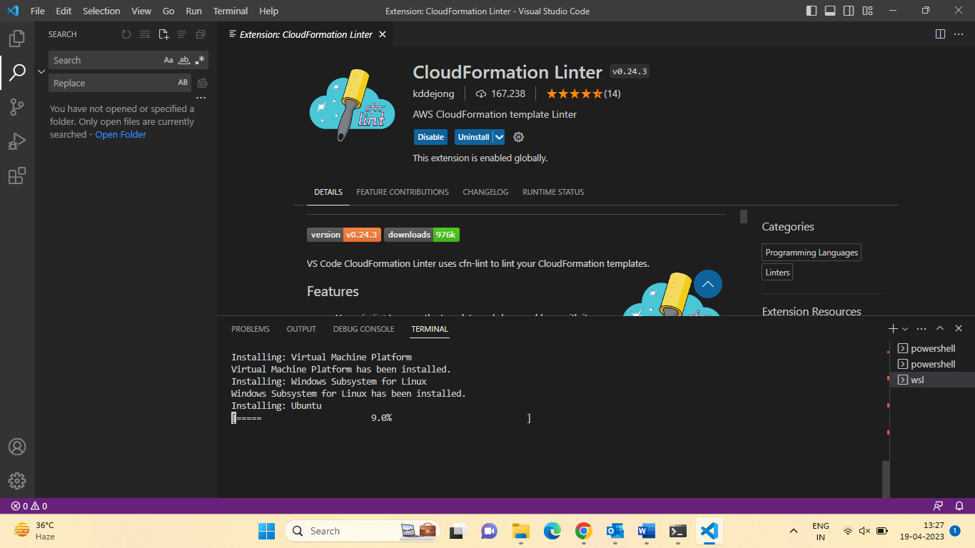

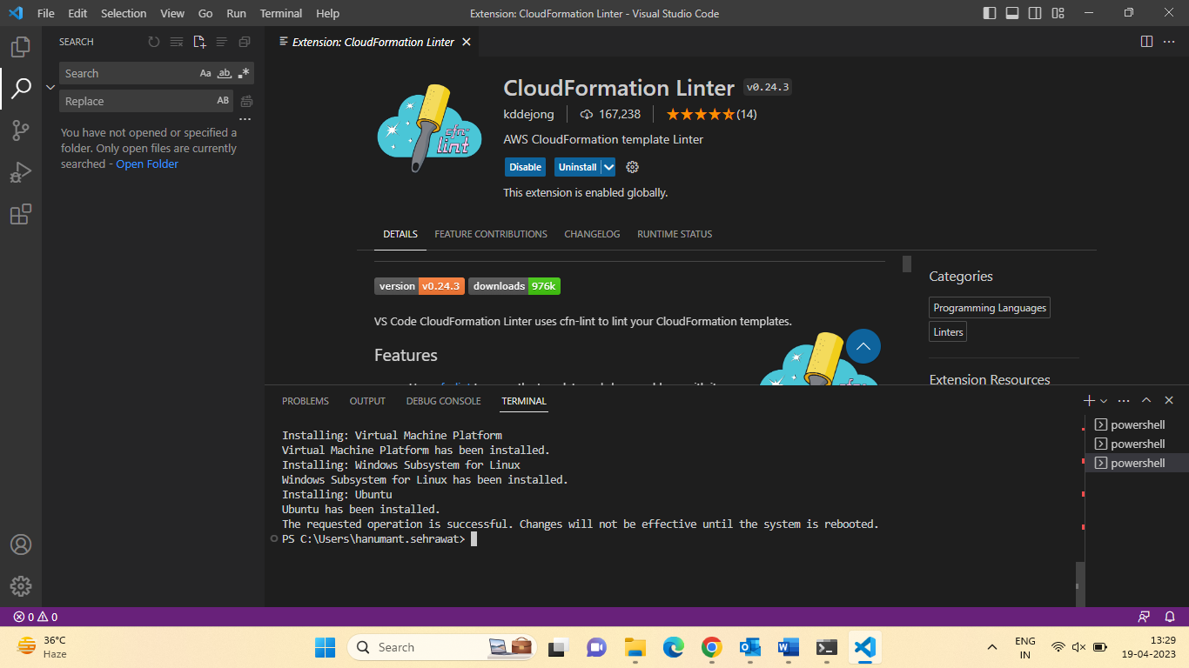

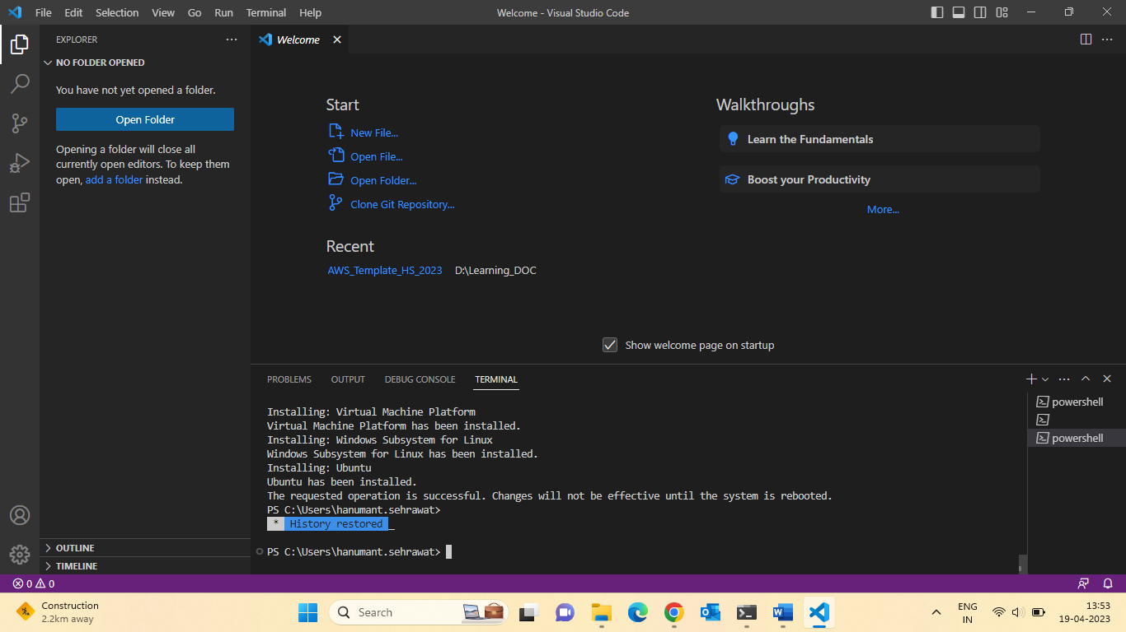

Also install python

Let install the CloudFormation extension in visual studio code.

1.CloudFormation Linter

In visual studio code install

1. pip install cfn-lint

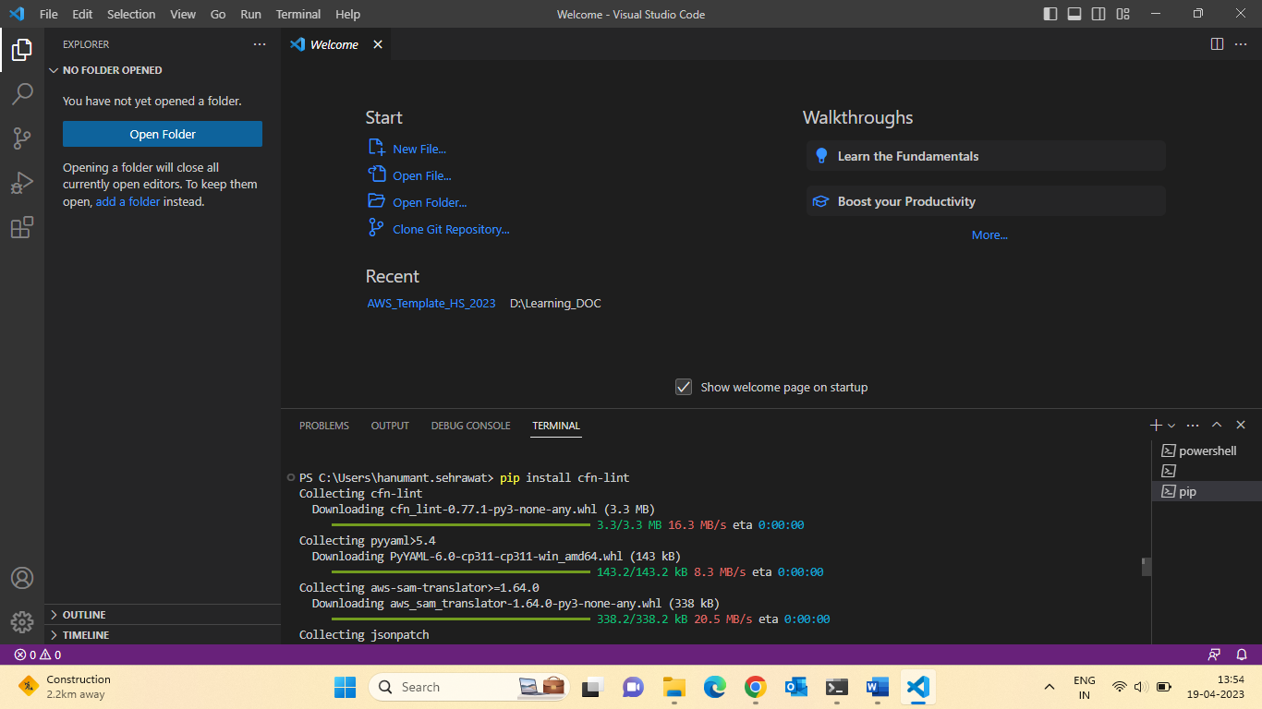

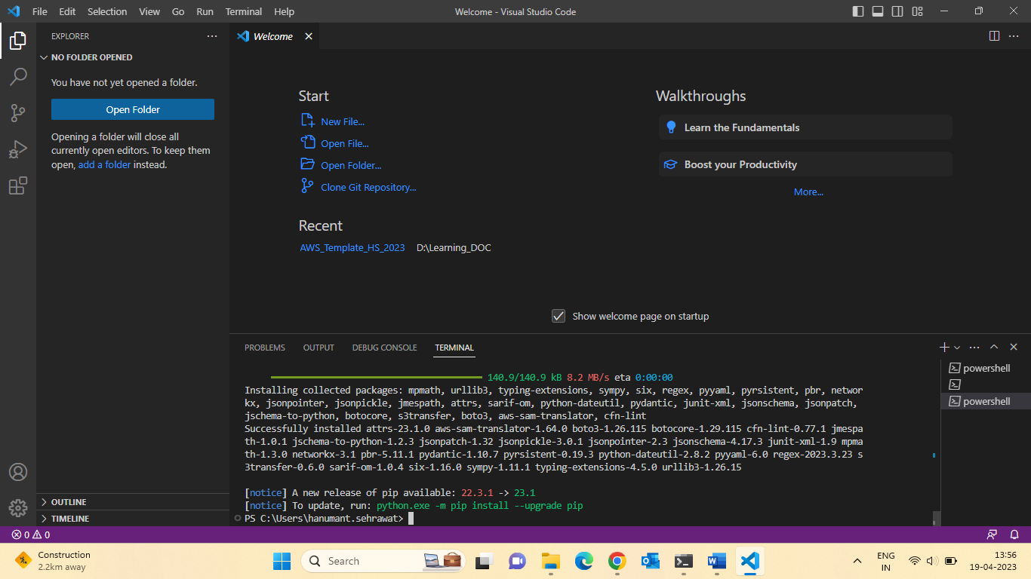

For install upgrade python:

Python.exe -m pip install -- upgrade pip

Pip install pydot

**Section 3: Cloud Formation Introduction:**

Introductory Example:

* We are going to create a simple EC2 Instance:
* Add we are going to add security group to it.

Webserver (open port :20,80)

WebServerSecurityGroup

* For now, forget about the code syntax.
* We all look at the structure of the files later.
* We will see how in no-time we are able to ger started with CloudFormation!!

First create the EC2 :

**Resources**:

**MyInstance:**

    Type: AWS::EC2::Instance

    Properties:

      AvailabilityZone: ap-south-1b

      ImageId: ami-07d3a50bd29811cd1

      InstanceType: t2.micro

Let update the EC2 open the some port:

**Resources**:

**MyInstance:**

    Type: AWS::EC2::Instance

    Properties:

      AvailabilityZone: ap-south-1b

      ImageId: ami-07d3a50bd29811cd1

      InstanceType: t2.micro

      SecurityGroups:

        - !Ref SSHSecurityGroup

        - !Ref ServerSecurityGroup

  # an elastic IP for our instance

**MyEIP:**

    Type: AWS::EC2::EIP

    Properties:

      InstanceId: !Ref MyInstance

  # our EC2 security group

**SSHSecurityGroup:**

    Type: AWS::EC2::SecurityGroup

    Properties:

      GroupDescription: Enable SSH access via port 22

      SecurityGroupIngress:

      - CidrIp: 0.0.0.0/0

        FromPort: 22

        IpProtocol: tcp

        ToPort: 22

  # our second EC2 security group

**ServerSecurityGroup:**

    Type: AWS::EC2::SecurityGroup

    Properties:

      GroupDescription: allow connections from specified CIDR ranges

      SecurityGroupIngress:

      - IpProtocol: tcp

        FromPort: 80

        ToPort: 80

        CidrIp: 0.0.0.0/0

      - IpProtocol: tcp

        FromPort: 22

        ToPort: 22

        CidrIp: 172.31.0.0/16

Let delete the stack & check ec2 delete automatically.

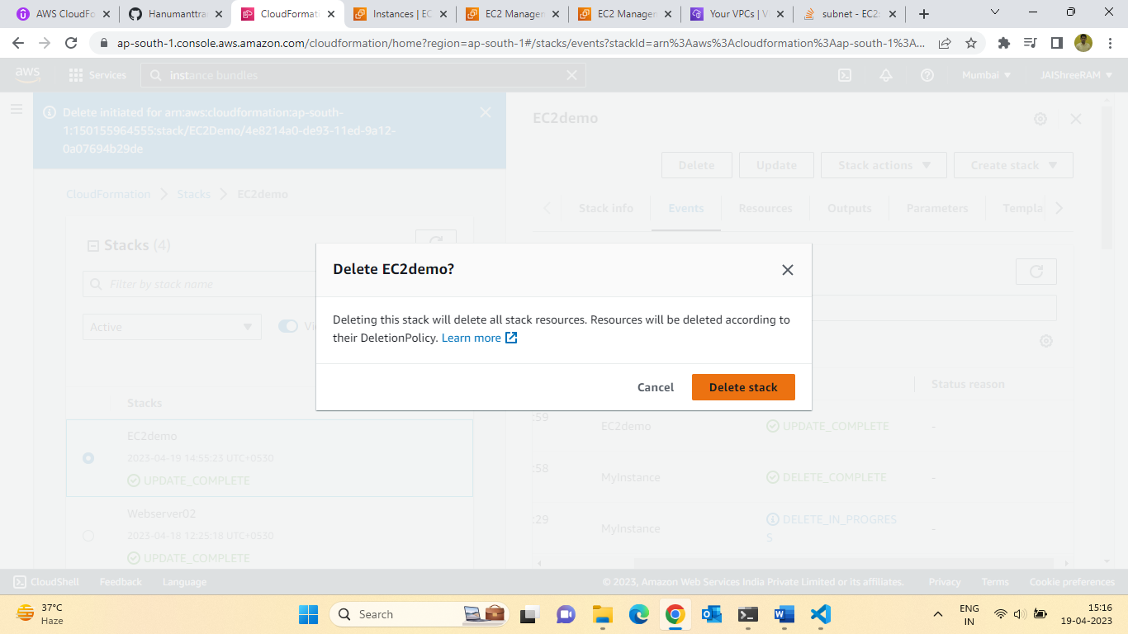

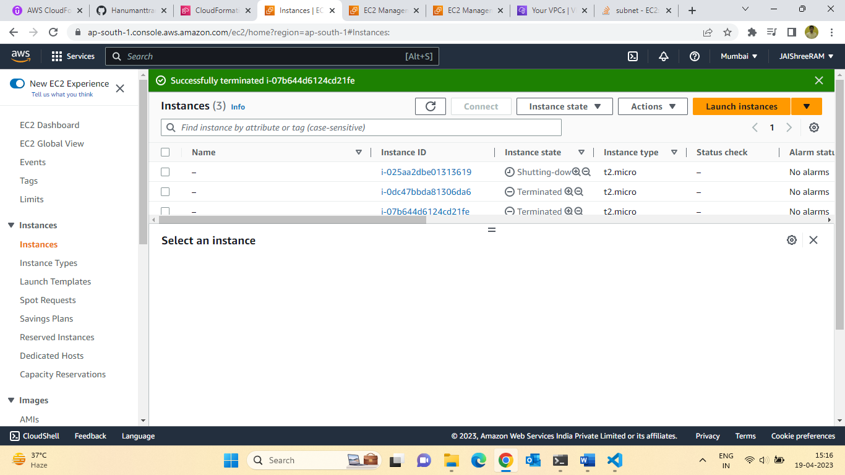

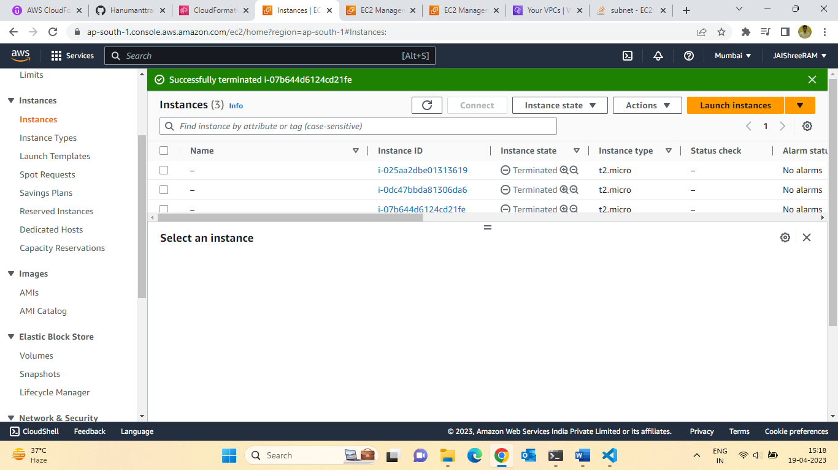

8.Summary of how cloud formation

How CloudFormation Works:

* Templates must be upload in S3 and the referenced in CloudFormation.
* TO Update a template, we cannot edit previous ones. We have to reupload a new version.

Of the template to AWS.

* Stacks are identified by a name.
* Deleting a stack deletes every single artifact that was created by CloudFormation.

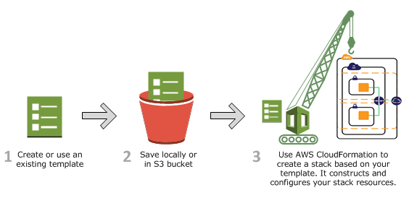

**CloudFormation Introduction Quiz**

Q.1 When you create a CloudFormation Stack, the CloudFormation template must be first uploaded to ...

Ans: Amazon Simple Storage Services (S3)

Q.2 To update a CloudFormation Stack, you can edit the previous CloudFormation template you uploaded before.

Ans:False

**9.YAML Tutorial:**

YAML Crash Course:

* YAML & JSON are the languages you can use for CloudFormation.
* JSON is horrible for CF.
* YAML is great in so many ways.
* Let’s learn a bit about it:
* Key Value Pairs
* Nested objects:
* Support Arrays (-)
* Multi line strings
* Can include comments!

Exercise: Try to convert this JSON in YAML

* Check out 2-First-Hands-on/0-exercise.json.

Url for covert JSON to YAML Code.

11.S3 Bucket Creation using CloudFormation:

Hands-On: Creating a S3 Bucket:

* Creating a S3 Bucket is free
* S3 is the AWS services for storing static files in a replicated and globally available way.
* It Powers many websites, Single Page Apps, Hosts, All the Netflix video content,
* We will use CloudFormation to provision a S3 Bucket!

**Resources**:

**MyS3Bucket:**

    Type: AWS::S3::Bucket

    Properties: {}

Let check the bucket is provision or not:

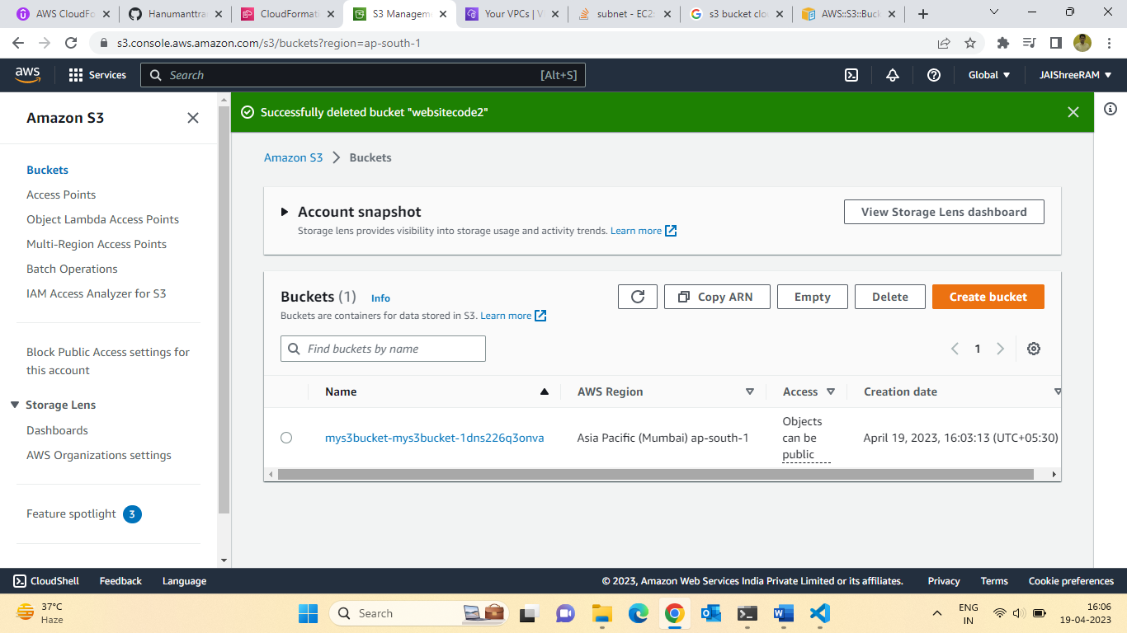

Let delete the stack of check automatic delete bucket:

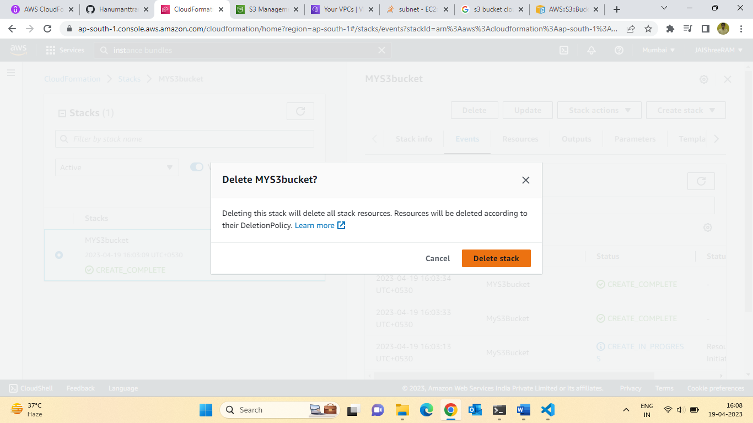

12: Let create the S3 Bucket for upgrading using CloudFormation:

CloudFormation Update Behaviour:

* CloudFormation updates resources based on difference between what you.

Submit and stack’s current template.

* Which method to use depends on which property you update for a resource.
* Update with No interruption
* Without disrupting resource operation & without changing physical ID.
* Example: Updating the IAM instance profile (IAMInstanceProfile) of an EC2 Instance.
* Update with Some interruption:
* Example: Updating an EC2 instance Type (InstanceType) from t2. micro to t2.small (etc).
* Replacement
* Recreating the resource with new physical ID.
* Creates the new resources, change reference from the other resource to the new resource, then deletes the old resource.
* Example, Updating an RDS DB instance availability zone (Availability Zone).

Hands -on: Updating a S3 Bucket:

* We will consider two types of updates:
* Updates with no interruption (adding Access Control)
* Replacement Updates (updating the name of the bucket)
* We will see how CloudFormation handles these two cases:

1st cases:

Updates with no interruption (adding Access Control)

**Resources**:

**MyS3Bucket:**

    Type: AWS::S3::Bucket

    Properties:

      AccessControl: PublicRead

2nd cases:

Replacement Updates (updating the name of the bucket)

**Resources**:

**MyS3Bucket:**

    Type: AWS::S3::Bucket

    Properties:

      AccessControl: PublicRead

      BucketName: "mys3bucket21234"

Topics :13 Deleting an S3 Bucket using cloud Formation:

Hands-on: deleting a S3 bucket:

* You can’t delete a non-empty S3 Bucket
* To delete a non-empty S3 Bucket, you must delete all the objects inside it first.
* We’ll delete our stack and see how CloudFormation reacts.

Let delete the Stack & Check if bucket is delete or not.

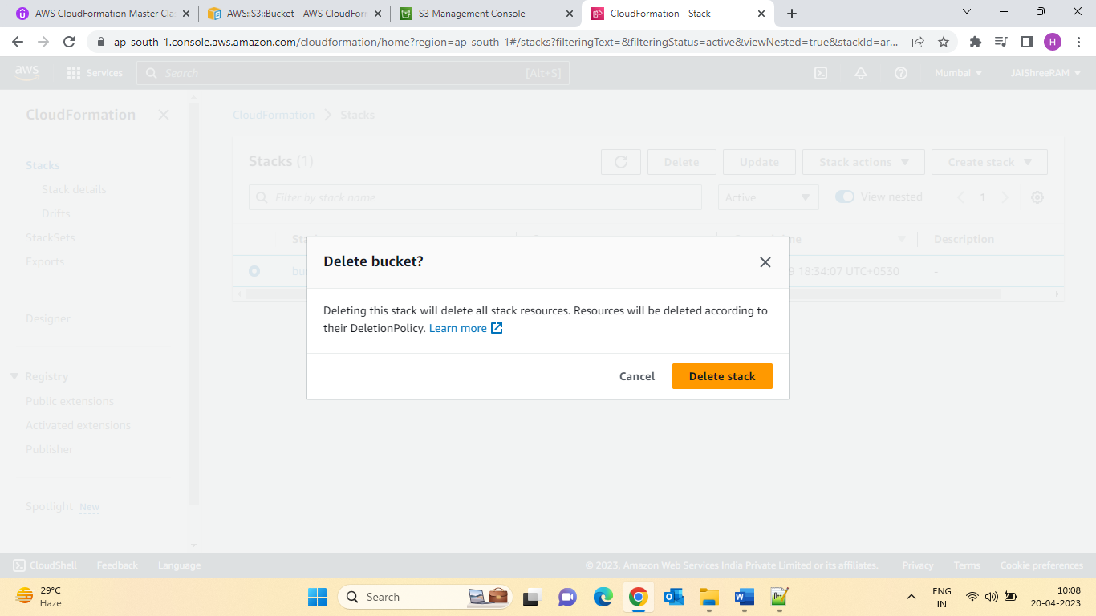

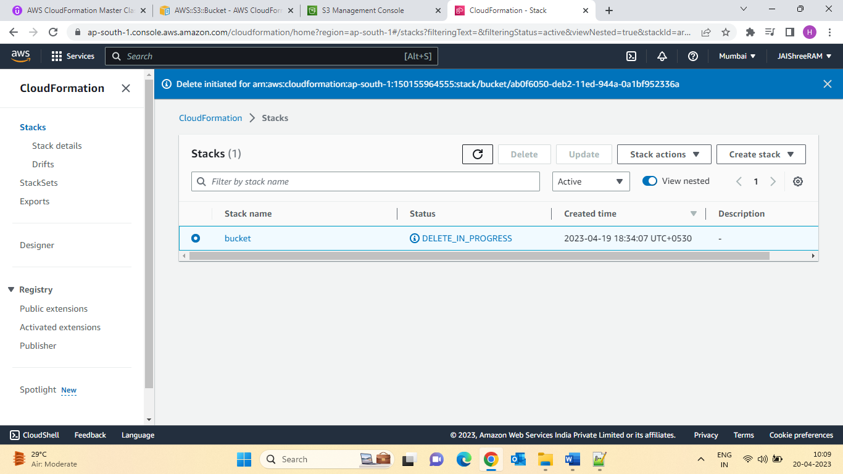

My Bucket is deleted :

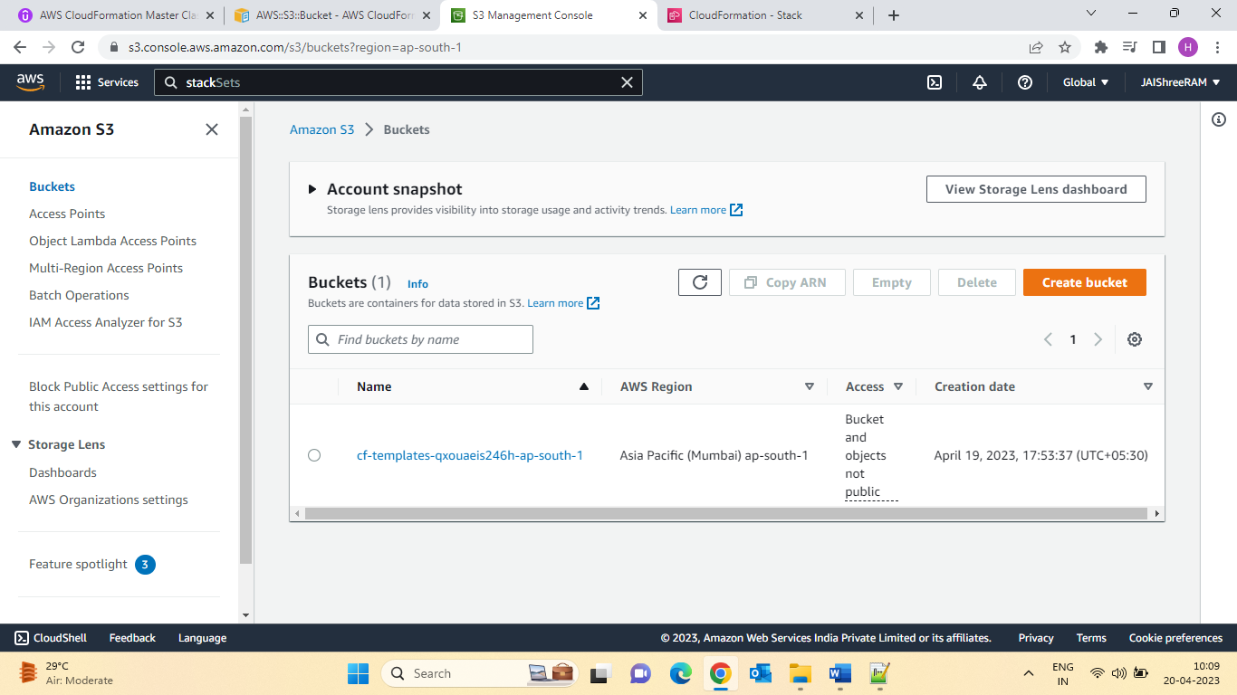

14.CloudFormation Templates Options:

Understanding the CloudFormation Template Options:

* Let’s learn about the parameters that are common to any CloudFormation template.
* Tags
* Permissions
* Notification Options
* Timeout
* Rollback on Failure
* Rollback Configuration (Monitoring time & CloudWatch Alarm)
* Stack Policy
* Termination Protection
* Quick-Start Link
* We’ will discuss them in greater details during the course!!

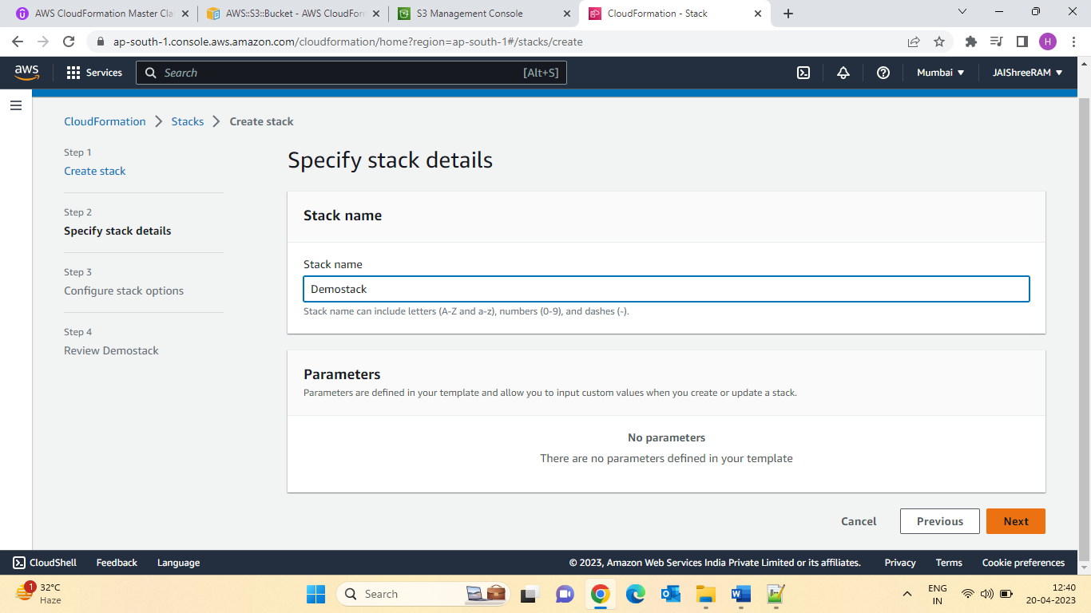

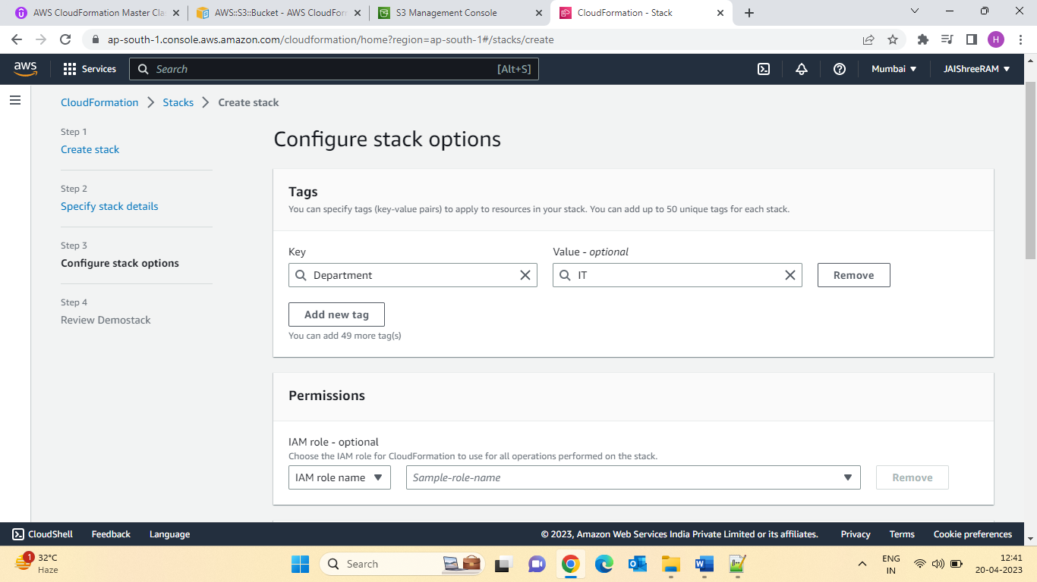

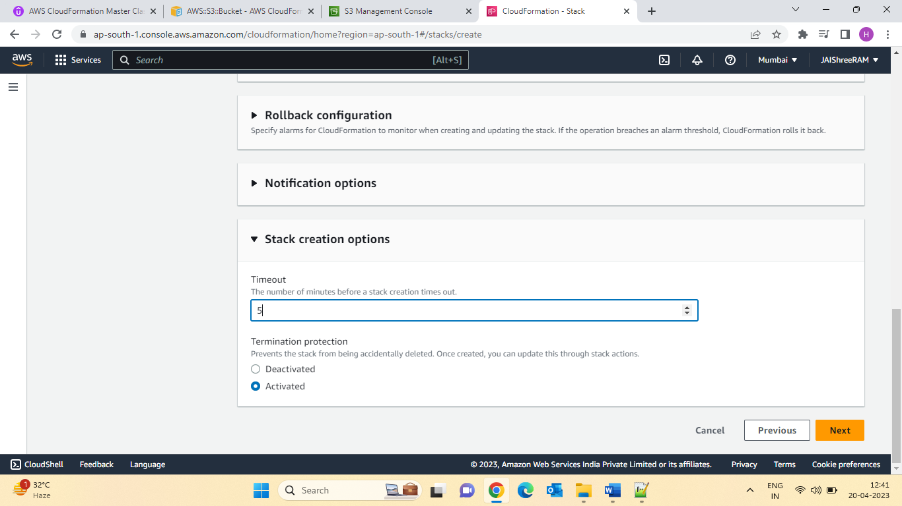

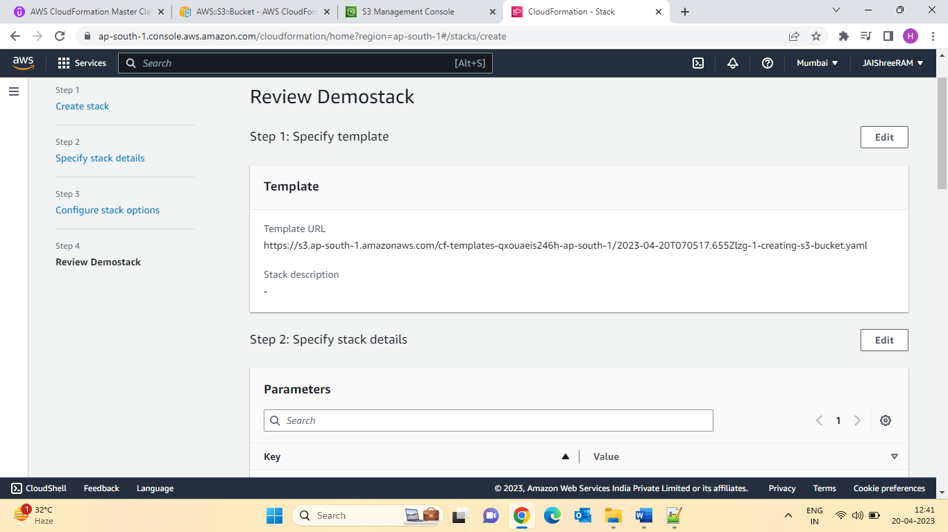

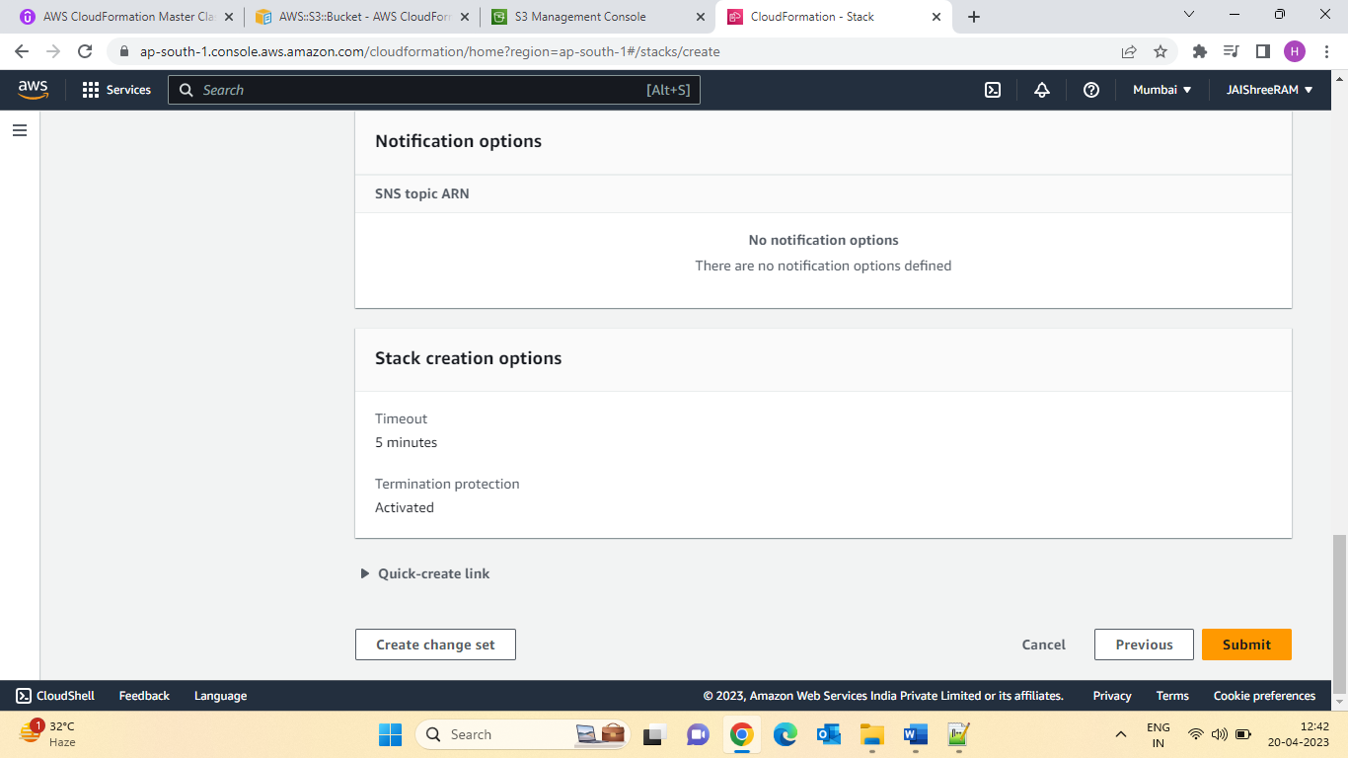

Let check the preview in S3Bucket:

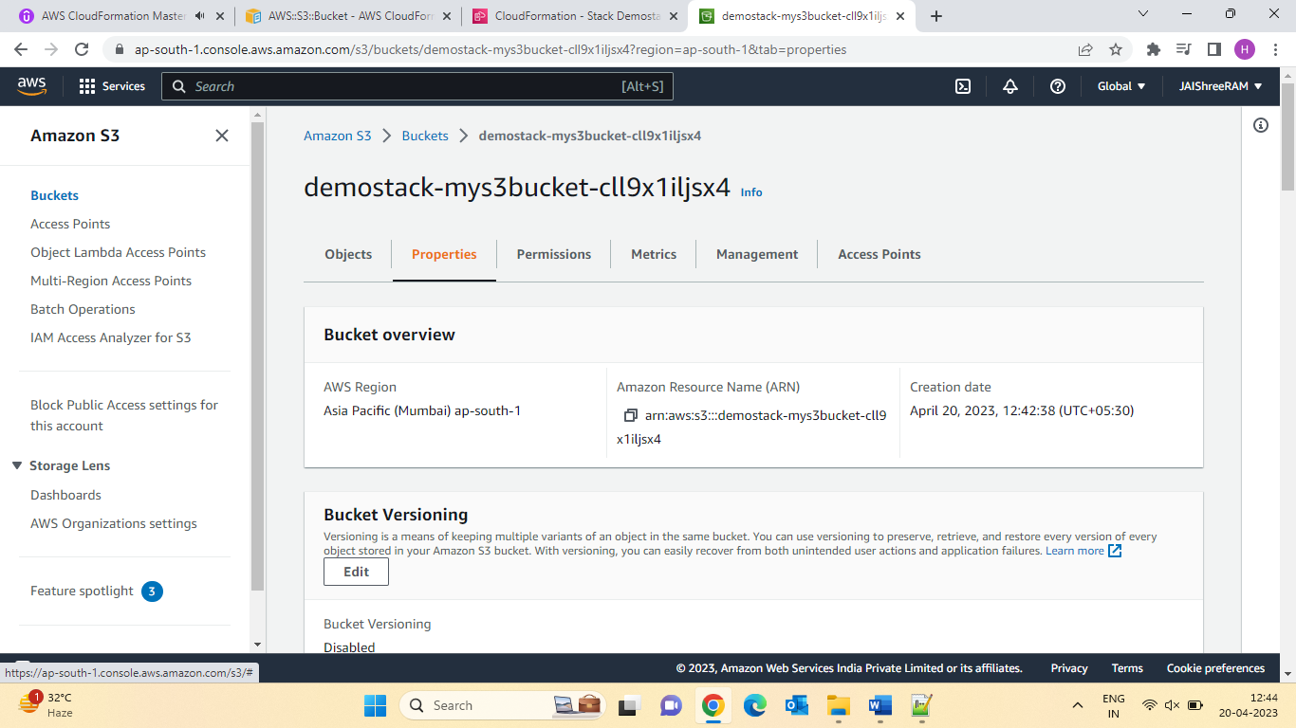

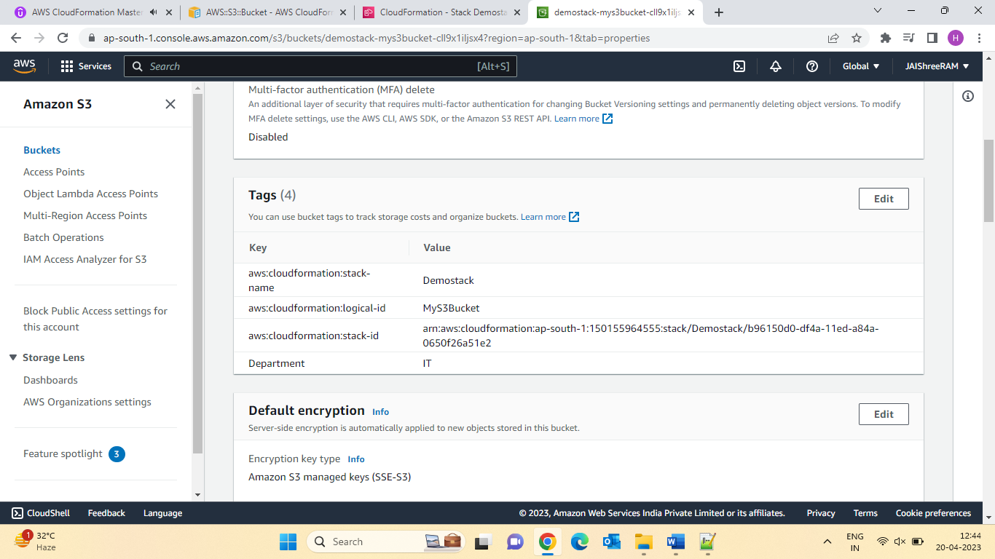

15.Using CloudFormation Designer:

* The CloudFormation Designer can really help visualize a CloudFormation stack.
* It ‘also very handy to just quickly draft a CloudFormation template.
* It has strong capabilities to verify that your template is also well written.
* Let’s learn how to use it!.

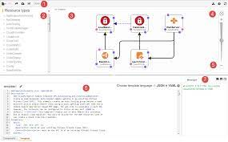

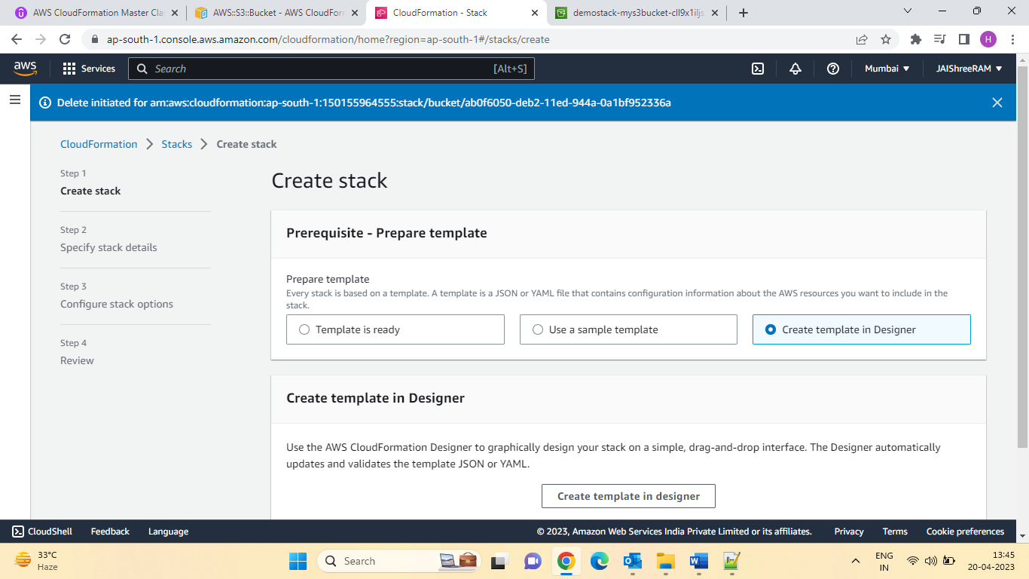

16.CloudFormation Building Blocks:

Template’s Components (one course section for each 4-10):

1. AWS Template Format Version: identifies the capabilities of the template (“2010-09-09”)
2. Description comments about the template.
3. Transform: specifies one or more Macros that used to process the template
4. Metadata
5. Resources: Your AWS resources declared in the template (MANDATORY)
6. Parameters: the dynamic inputs for your template
7. Mappings: the static variables for your template
8. Outputs: Reference to what has been created
9. Conditionals: List of conditions to perform resource creation
10. Rules: validate a parameter(s) during stack creation/update

Templates’ helpers (learning as we encounter them):

1. references:
2. Functions

Section 17: Deploying CloudFormation Templates:

* Manual Way:
* Editing templates in CloudFormation Designer or code editor
* Using the console to input parameters, etc…
* We will mostly do this way in the course for learning purposes.

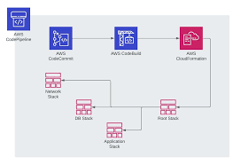

* Automated Way:
* Editing templates in a YAML File
* Using the AWS CLI (command line interface) to deploy the templates, or using a Continuous Delivery (CD) tool .
* Recommended way when you fully want to automate your flow.
* We’ll learn about it in the advanced section of the course.

Section 18: Cost estimates for your templates:

Quiz 3: Getting started Quiz.

Q.1.You can write CloudFormation templates using ....

Ans:Either JSON Or YAML

Q.2.When you update a CloudFormation stack, there is a probability that the updated resource will be replaced with a new one. What is the name of this Update Behaviour?

Ans: Replacement

Q.3. What tool can be used to automate CloudFormation template deployments?

Ans:AWS Cli.

Q.4. Which of the following is not part of the CloudFormation building blocks?

Ans:Security Groups

Section 5: Cloud Formation Parameters:

What are parameters?

* Parameters are way to provide inputs to your AWS CloudFormation template.
* They are important to Know about if:
* You want to reuse your templates across the company.
* Some inputs cannot determine ahead of time.
* Parameters are extremely powerful, controlled and can prevent errors from happing in your templates, thanks to types.
* Parameters can be cross validated using Rules (later in the course).

When should you use a parameter?

* Ask yourself this:
* Is this CloudFormation resource configuration likely to change in the future?
* If so, make it a parameter.
* You won’t have to re-upload a template to change its content.

For example:

**Parameters**:

**SecurityGroupDescrption:**

**Type:** String

**Description:** Security Group Description (simple parameter)

Parameters Settings:

* Parameters can be controlled by all these settings:
* Type
  + - String
    - Number
    - Comma Delimited List
    - List<Number>
    - AWS-Specific Parameter (to Help catch invalid -match against existing value in the AWS Account).
    - List<AWS-Specific Parameter>
    - SSM Parameter (get parameter value from SSM Parameter store)
    - Description
    - Constraint Description (String)
    - Min/Max length
    - Min/Max Value
    - Default
    - AllowedValues(Array)
    - Allowedpattern(regex)
    - NoEcho (Boolean)

How to Reference a Parameter

* The Fn::Ref function can be leveraged to reference parameters.
* Parameters can be user anywhere in a template, except:
* AWSTempalteFormatVersion
* Description
* Transform
* Mappings
* The shorthand for this in YAML is !Ref

For example:

DBsubnet1:

**Type:** AWS::EC2::Subnet

**Properties:**

   VpcId: !Ref Myvpc

* The function can also reference other elements within the template:

Date:21-04-2023

Parameters Hands-on

**Parameters**:

**SecurityGroupDescription:**

    Description: Security Group Description (Simple parameter)

    Type: String

**SecurityGroupPort:**

    Description: Simple Description of a Number Parameter, with MinValue and MaxValue

    Type: Number

    MinValue: 1150

    MaxValue: 65535

**InstanceType:**

    Description: WebServer EC2 instance type (has default, AllowedValues)

    Type: String

    Default: t2.small

    AllowedValues:

      - t1.micro

      - t2.nano

      - t2.micro

      - t2.small

    ConstraintDescription: must be a valid EC2 instance type.

**DBPwd:**

    NoEcho: true

    Description: The database admin account password (won't be echoed)

    Type: String

**KeyName:**

    Description: Name of an existing EC2 KeyPair to enable SSH access to the instances. Linked to AWS Parameter

    Type: AWS::EC2::KeyPair::KeyName

    ConstraintDescription: must be the name of an existing EC2 KeyPair.

**SecurityGroupIngressCIDR:**

    Description: The IP address range that can be used to communicate to the EC2 instances

    Type: String

    MinLength: '9'

    MaxLength: '18'

    Default: 0.0.0.0/0

    AllowedPattern: (\d{1,3})\.(\d{1,3})\.(\d{1,3})\.(\d{1,3})/(\d{1,2})

    ConstraintDescription: must be a valid IP CIDR range of the form x.x.x.x/x.

**MyVPC:**

    Description: VPC to operate in

    Type: AWS::EC2::VPC::Id

**MySubnetIDs:**

    Description: Subnet IDs that is a List of Subnet Id

    Type: "List<AWS::EC2::Subnet::Id>"

**DbSubnetIpBlocks:**

    Description: "Comma-delimited list of three CIDR blocks"

    Type: CommaDelimitedList

    Default: "10.0.48.0/24, 10.0.112.0/24, 10.0.176.0/24"

**Resources**:

**MyEC2Instance:**

    Type: AWS::EC2::Instance

    Properties:

      #we reference the InstanceType parameter

      InstanceType: !Ref InstanceType

      KeyName: !Ref KeyName

      ImageId: ami-0742b4e673072066f

      # here we reference an internal CloudFormation resource

      SubnetId: !Ref DbSubnet1

**MySecurityGroup:**

    Type: AWS::EC2::SecurityGroup

    Properties:

      GroupDescription: !Ref SecurityGroupDescription

      SecurityGroupIngress:

        - CidrIp: !Ref SecurityGroupIngressCIDR

          FromPort: !Ref SecurityGroupPort

          ToPort: !Ref SecurityGroupPort

          IpProtocol: tcp

      VpcId: !Ref MyVPC

**DbSubnet1:**

    Type: AWS::EC2::Subnet

    Properties:

      VpcId: !Ref MyVPC

      # the select function allows us to select across a list

      CidrBlock: !Select [0, !Ref DbSubnetIpBlocks]

**DbSubnet2:**

    Type: AWS::EC2::Subnet

    Properties:

      VpcId: !Ref MyVPC

      # the select function allows us to select across a list

      CidrBlock: !Select [1, !Ref DbSubnetIpBlocks]

**DbSubnet3:**

    Type: AWS::EC2::Subnet

    Properties:

      VpcId: !Ref MyVPC

      # the select function allows us to select across a list

      CidrBlock: !Select [2, !Ref DbSubnetIpBlocks]

Advanced SSM Parameter Type:

SSM Parameter Type:

* Refrencer parameters in Systems Manager Parameter Store
* Specify SSM parameter key as the values.
* CloudFormation always fetches the latest value (you Can’t specify parameter version)
* CloudFormation doesn’t store Secure String values.
* Validation done on SSM parameter keys, but not values.
* Supported SSM Parameter Types:
* AWS:SSM::Parameter::Name
* AWS:SSM:Parameter::Name
* AWS::SSM:Parameter::Value<List<String>>or
* AWS::SSM:Parameter:Value<Commadelmitedlist>
* AWS:SSM::Parameter:Value<AWS-Specific Parameter>
* AWS::SSM: Parameter::Value<List<AWS-Specific Parameter>>
* AWS::SSM::Parameter::Value<List<AWS-Specific Parameter>>

Example: Fetch Latest AMI IDs

Fetch Latest AMI IDs From SSM Parameter Store (AWS Public Parameters)

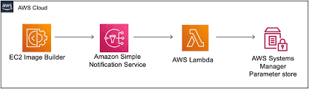

22: Advanced -SSM Parameter Types Hands on:

**Parameters**:

**InstanceType:**

    Description: WebServer EC2 instance type

    Type: AWS::SSM::Parameter::Value<String>

    Default: /dev/ec2/instanceType

**ImageId:**

    Type: AWS::SSM::Parameter::Value<AWS::EC2::Image::Id>

    Default: /aws/service/ami-amazon-linux-latest/amzn2-ami-hvm-x86_64-gp2

**Resources**:

**MyEC2Instance:**

    Type: AWS::EC2::Instance

    Properties:

      InstanceType: !Ref InstanceType

      ImageId: !Ref ImageId

[https://ap-south-1.console.aws.amazon.com/systems-manager/parameters?region=ap-south-1#](https://ap-south-1.console.aws.amazon.com/systems-manager/parameters?region=ap-south-1)

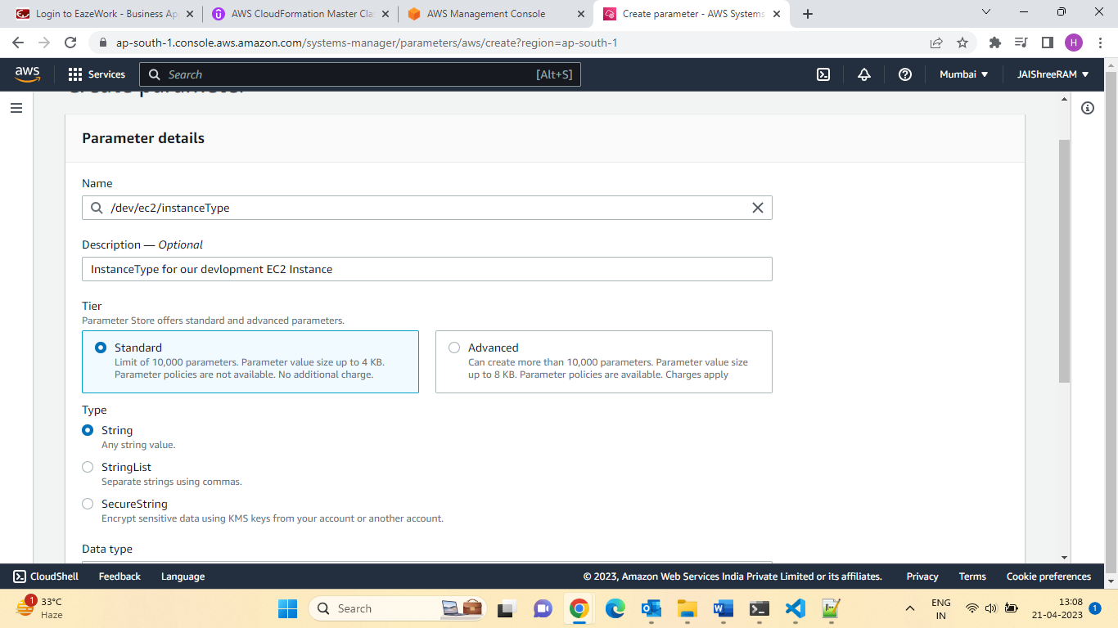

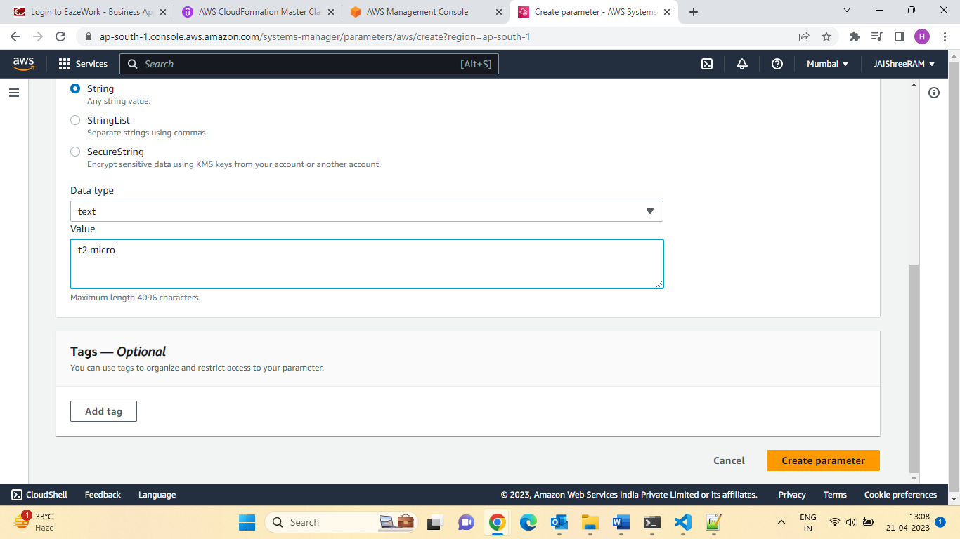

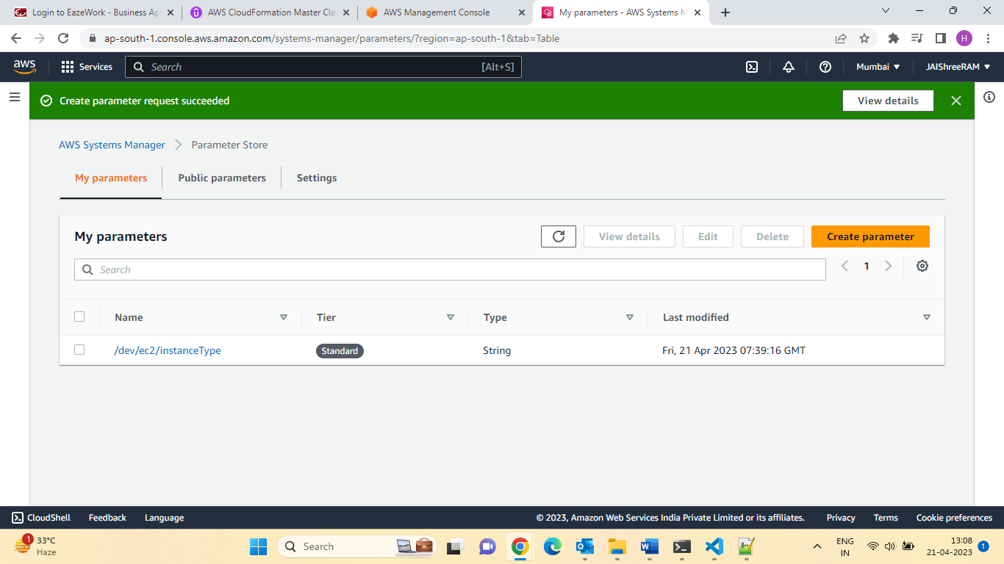

2nd Parameters:

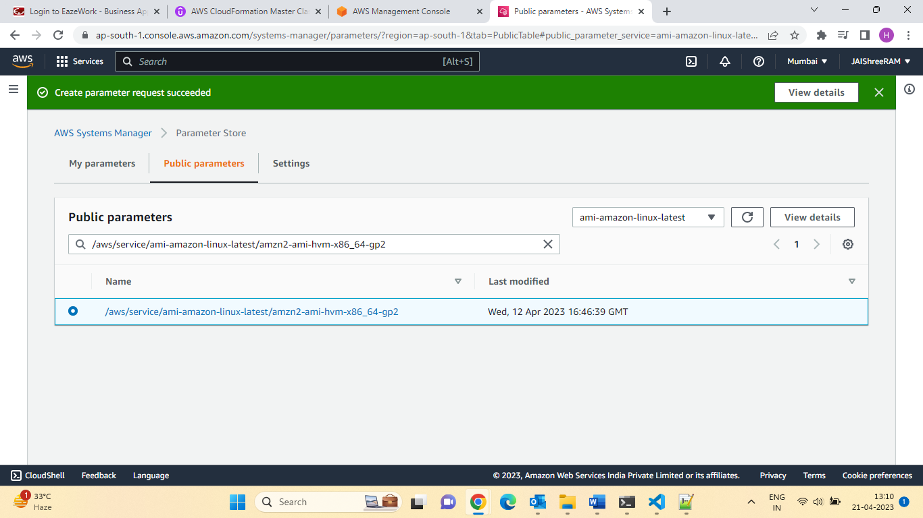

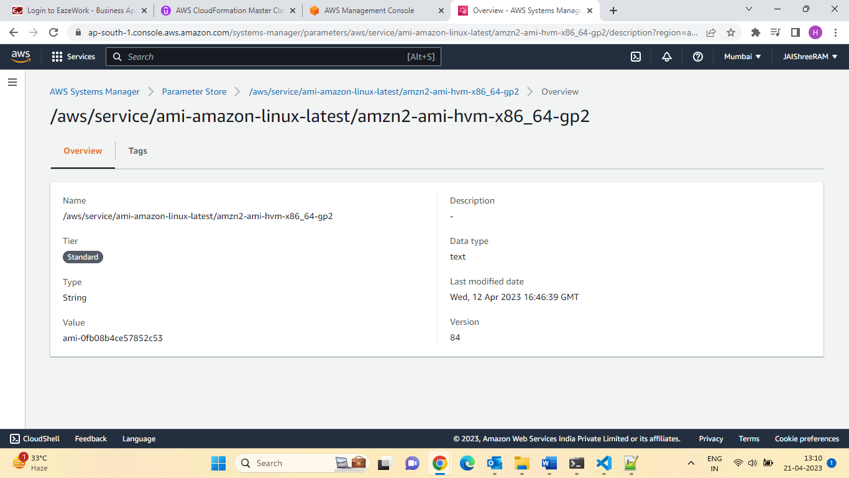

Let create the Stack :

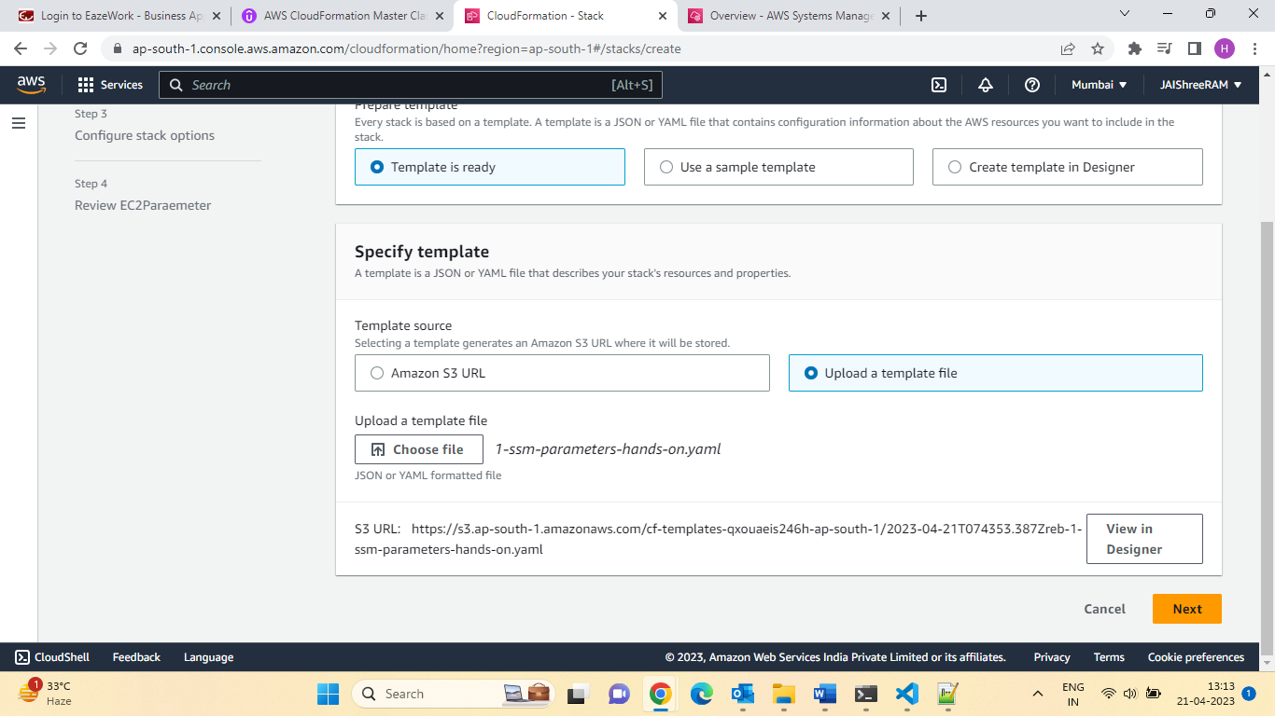

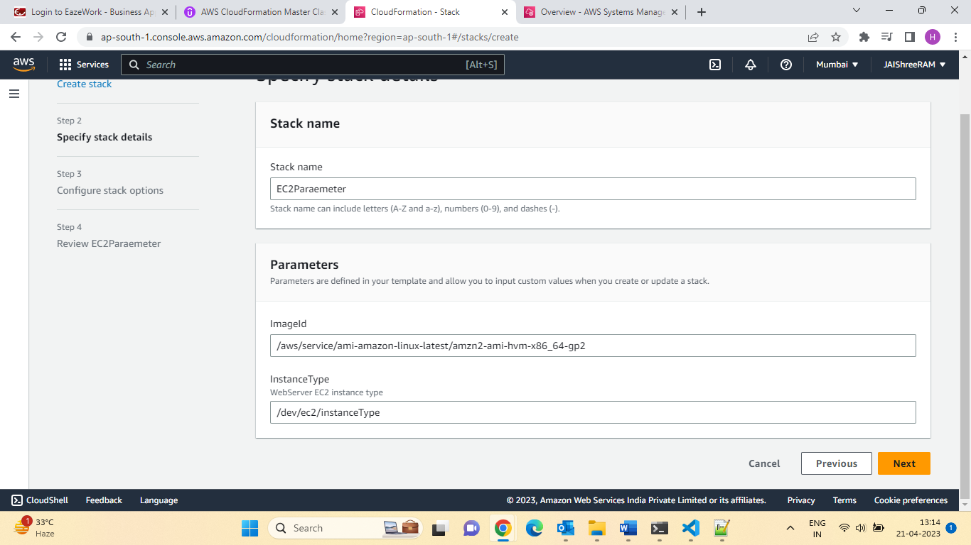

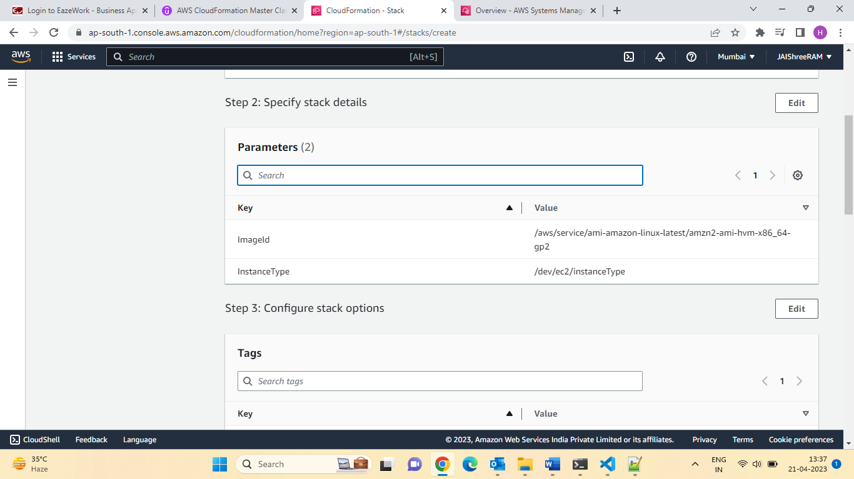

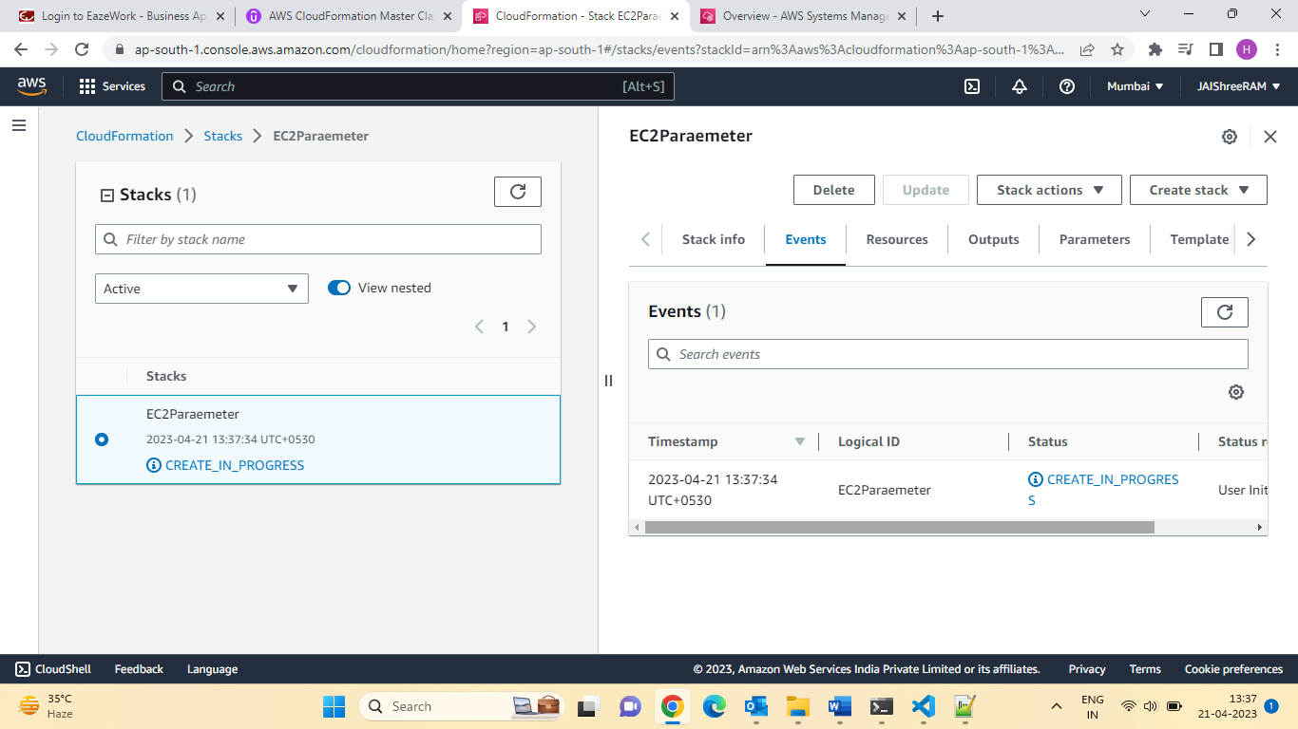

Quiz4:

Question 1:

You want to reuse the CloudFormation template based on input provided by the user. What would you use to achieve this?

Ans:Parameters

Q.2 Which of the following parameter's attributes is used to prevent a parameter value from being seen in the AWS Console, CLI, or API?

Ans:NoEcho

Q.3. **Fn::Ref**intrinsic function used to reference parameters from the CloudFormation template.

Ans:True

Q.4. Which parameter type would you use to reference parameter values in AWS Systems Manager Parameter Store?

Ans:AWS::SSM::Parameter::Value<String>

Section 6: CloudFormation Resources:

<https://docs.aws.amazon.com/AWSCloudFormation/latest/UserGuide/aws-template-resource-type-ref.html>

<https://docs.aws.amazon.com/AWSCloudFormation/latest/UserGuide/aws-properties-ec2-instance.html>

What are the resources?

* Resources are the core of your CloudFormation template (Mandatory)
* They represent the different AWS Components that will be created and configured.
* Resources are declared and can reference each other.
* AWS figure out creation, updates and deletes of resources for us.
* There are over 700 types of resources (!)
* Resource types identifiers are of the form:

AWS: ::aws-product-name:: data-type-name

How do I find resources documentation?

* I can’t teach you all the 700+resources, but I can teach you how to learn how to use them.
* All the resource can be found here:

<http://docs.aws.amazon.com/AWSCloudFormation/latest/UserGuide/aws-template-resource-type-ref.html>

* Then, we just read the docs:
* Example, here (for an EC2 Instance):

<https://docs.aws.amazon.com/AWSCloudFormation/latest/UserGuide/aws-properties-ec2-instance.html>

<https://docs.aws.amazon.com/AWSCloudFormation/latest/UserGuide/aws-properties-ec2-instance.html#aws-properties-ec2-instance--examples>

Section 24: Resources Hands on :

Templates:

**Resources**:

**MyInstance:**

    # http://docs.aws.amazon.com/AWSCloudFormation/latest/UserGuide/aws-properties-ec2-instance.html

    Type: AWS::EC2::Instance

    Properties:

      ImageId: ami-0742b4e673072066f

      InstanceType: t2.micro

      SecurityGroups:

        - !Ref SSHSecurityGroup

        - !Ref ServerSecurityGroup

**MyEIP:**

    # http://docs.aws.amazon.com/AWSCloudFormation/latest/UserGuide/aws-properties-ec2-eip.html

    Type: AWS::EC2::EIP

    Properties:

      InstanceId: !Ref MyInstance

**SSHSecurityGroup:**

    # http://docs.aws.amazon.com/AWSCloudFormation/latest/UserGuide/aws-properties-ec2-security-group.html

    Type: AWS::EC2::SecurityGroup

    Properties:

      GroupDescription: Enable SSH access via port 22

      SecurityGroupIngress:

      - CidrIp: 0.0.0.0/0

        FromPort: 22

        IpProtocol: tcp

        ToPort: 22

**ServerSecurityGroup:**

    # http://docs.aws.amazon.com/AWSCloudFormation/latest/UserGuide/aws-properties-ec2-security-group.html

    Type: AWS::EC2::SecurityGroup

    Properties:

      GroupDescription: allow connections from specified CIDR ranges

      SecurityGroupIngress:

      - IpProtocol: tcp

        FromPort: 80

        ToPort: 80

        CidrIp: 0.0.0.0/0

      - IpProtocol: tcp

        FromPort: 22

        ToPort: 22

        CidrIp: 192.168.1.1/32

Section25: Optional attributes for Resource:

* Depends ON
* Very useful to draw a dependency between two resources.
* For example, only create an ECS cluster after creating an ASG (auto scaling group)
* Deletion Policy:
* Protect resources from being deleted even of the CloudFormation stack is deleted)(Ex; an RDS database)

UpdateReplacePolicy:

* Protect resources from being replaced during a cloud formation update.

Optional attributes for Resource:

* Depends ON
* Very useful to draw a dependency b/w 2 resources.
* For example. One creates an ECS cluster after creating an ASG (Auto scaling group)
* Deletion Policy:
* Protect resource from being deleted even if the CloudFormation stack is deleted (Ex.An RDS Database)

UpdateReplacePolicy:

* Protect resource from being replaced during a CloudFormation update.
* Creation Policy: More details in the CFN Init Section
* Update Policy: For some specific resource (example: ASG) Discussed later.
* Metadata: anything you want
* +Examples in the CFN Init Section:

Section 26: Depends On

* Specify that the creation of a specific resources follows another.
* When added to a resource, that resource is created only after the creation of resource specified in the Depends On attribute.
* Applied automatically when using! Ref and !GetAtt
* Use with Any resource.

**Resources**:

**MyEC2Instance:**

    Type: :AWS::EC2::Instance

    Properties:

    ImageId:ami-0742b4e673072066f

    DependsOn: MyDB

    MyDB:

    Type: AWS::RDS::DBInstance

    Properties:

    DBInstanceClass: db.t2.small

    Engine: MySQL

Let try it :

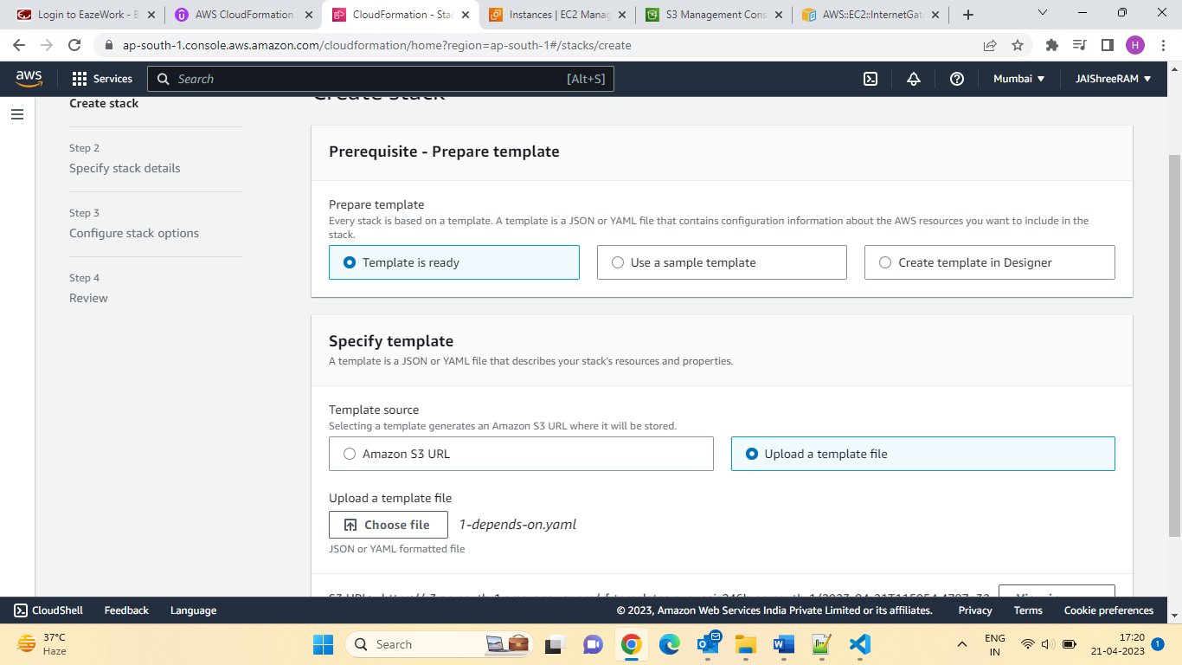

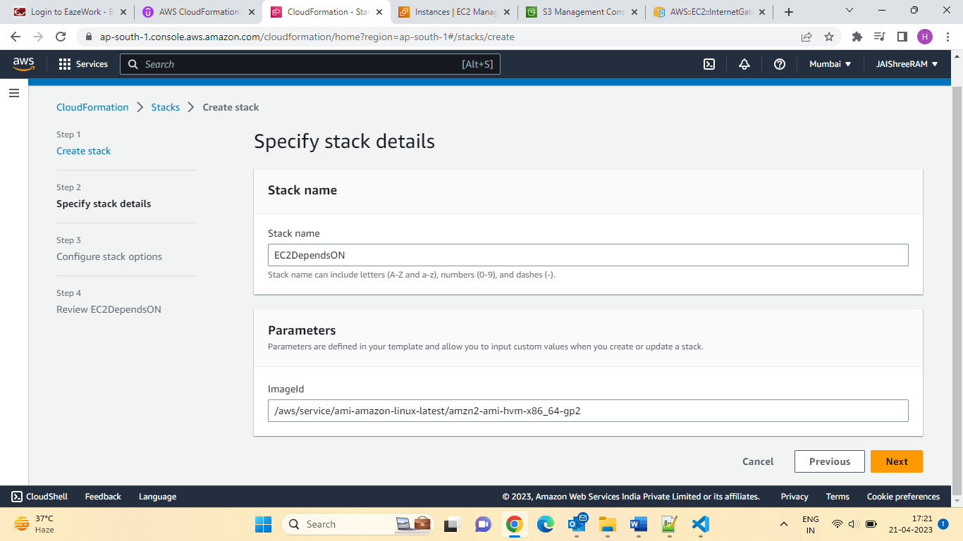

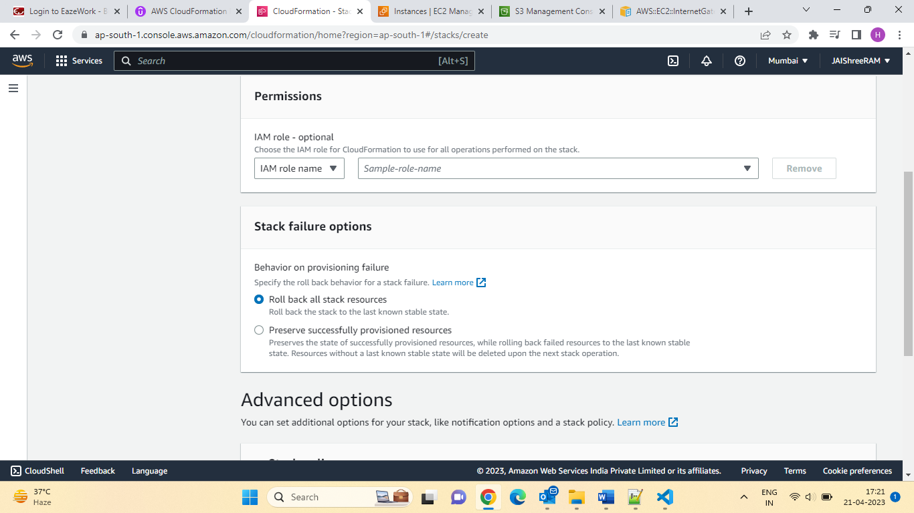

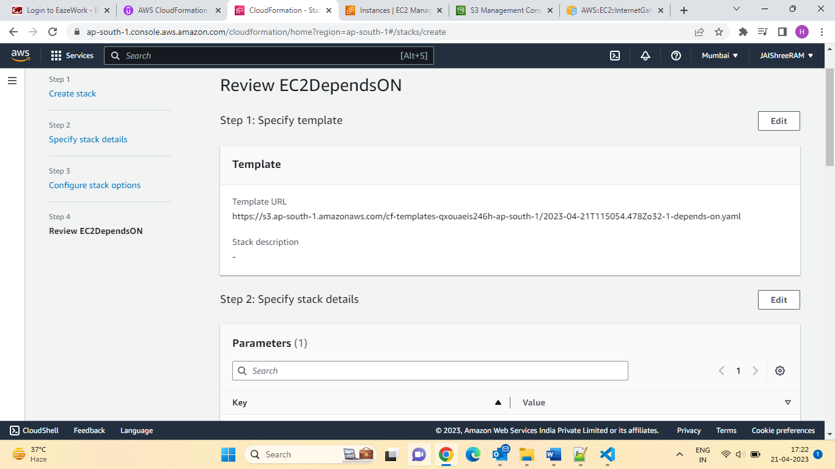

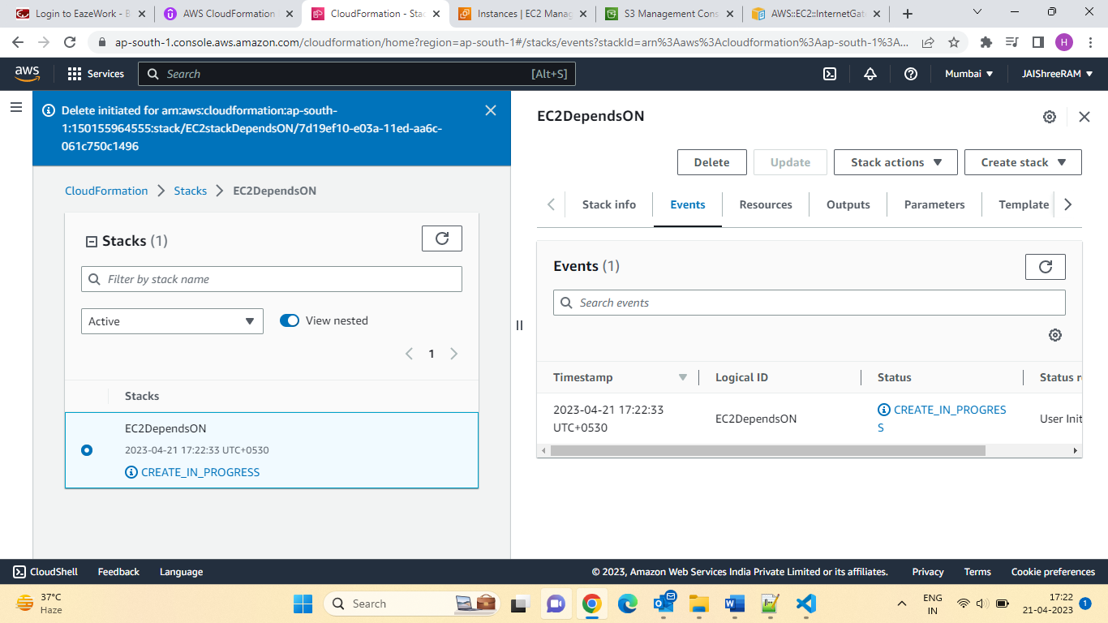

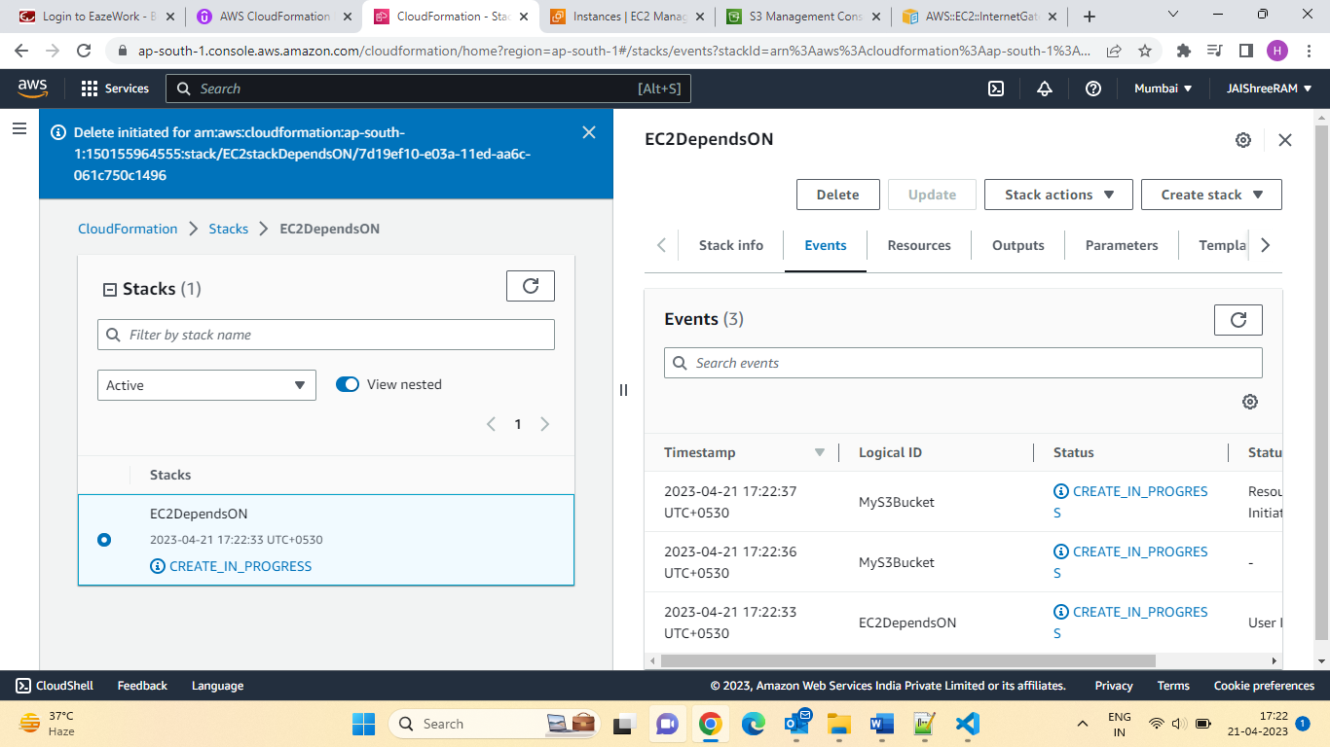

Let check s3 Bucket created or not;

Bucket found:

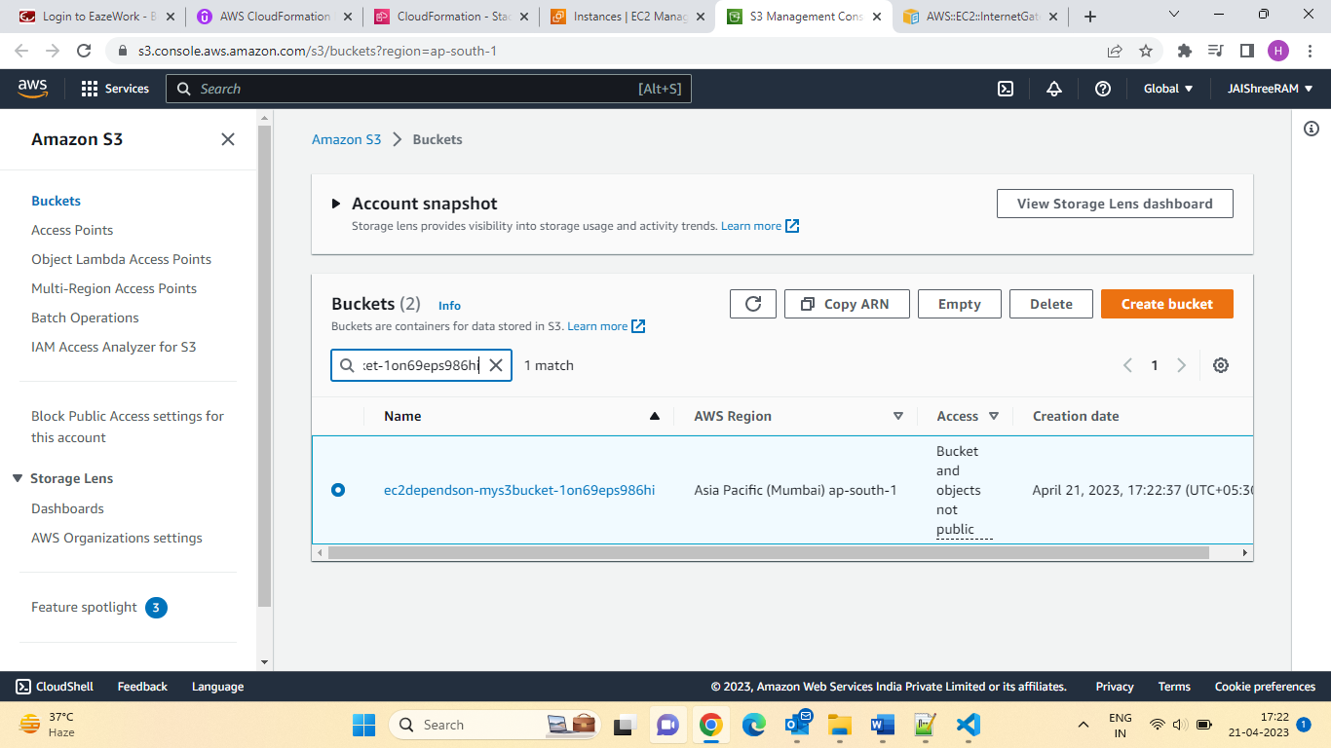

let check the status of EC2:

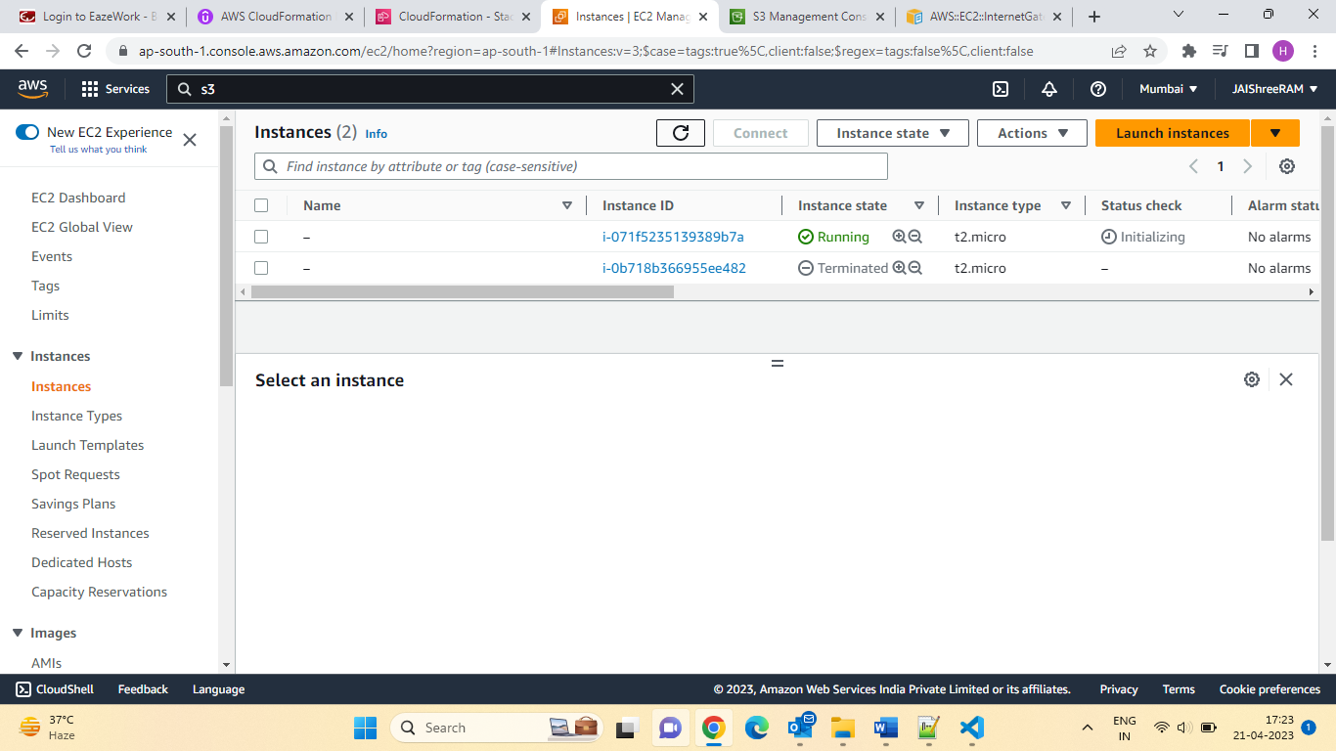

Section 27: Deletion Policy

* Control What happens when the CloudFormation template is deleted or when a resource is removed directly from a CloudFormation template.
* Use with any resource.
* Deletion Policy=Retain:
* Specify on resource to preserver/backup in case of CloudFormation deletes.
* TO keep a resource, specify Retain (works for any resource /nested stack)
* Deletion Policy=Snapshot:
* EBS Volume, ElastiCache Cluster, ElastiCache Replication Group
* RDS DB Instance, RDS DB Cluster, RedShift Cluster, Neptune DB Cluster

Deletion Policy=Delete (default Behaviour):

* Note: For AWS::RDS::DB Cluster resource, the default policy is Snapshot
* Note: For AWS::RDS::DB Instance resources that don’t specify the DBCluserIndentifier property the default policy is Snapshot.
* Note: To delete an S3 Bucket, you need to first empty the bucker of its content.

Let do the Demo of Delete policy:

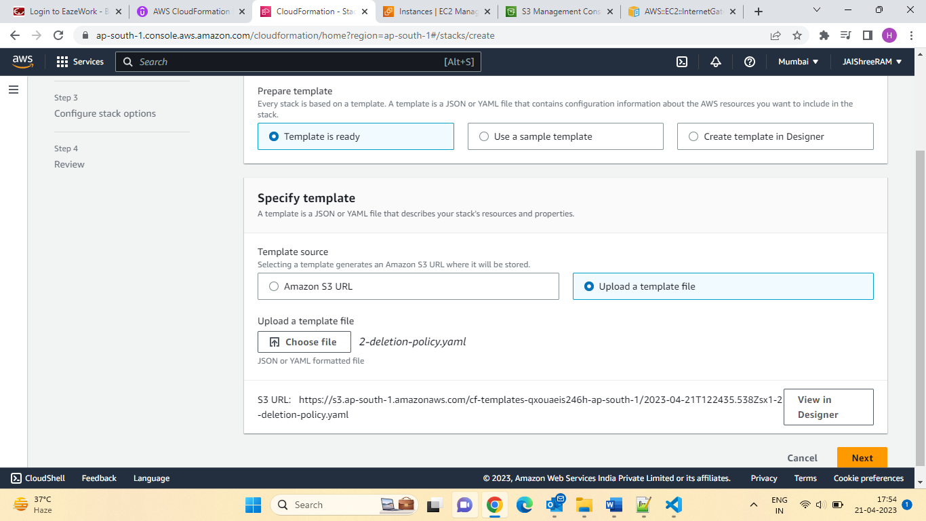

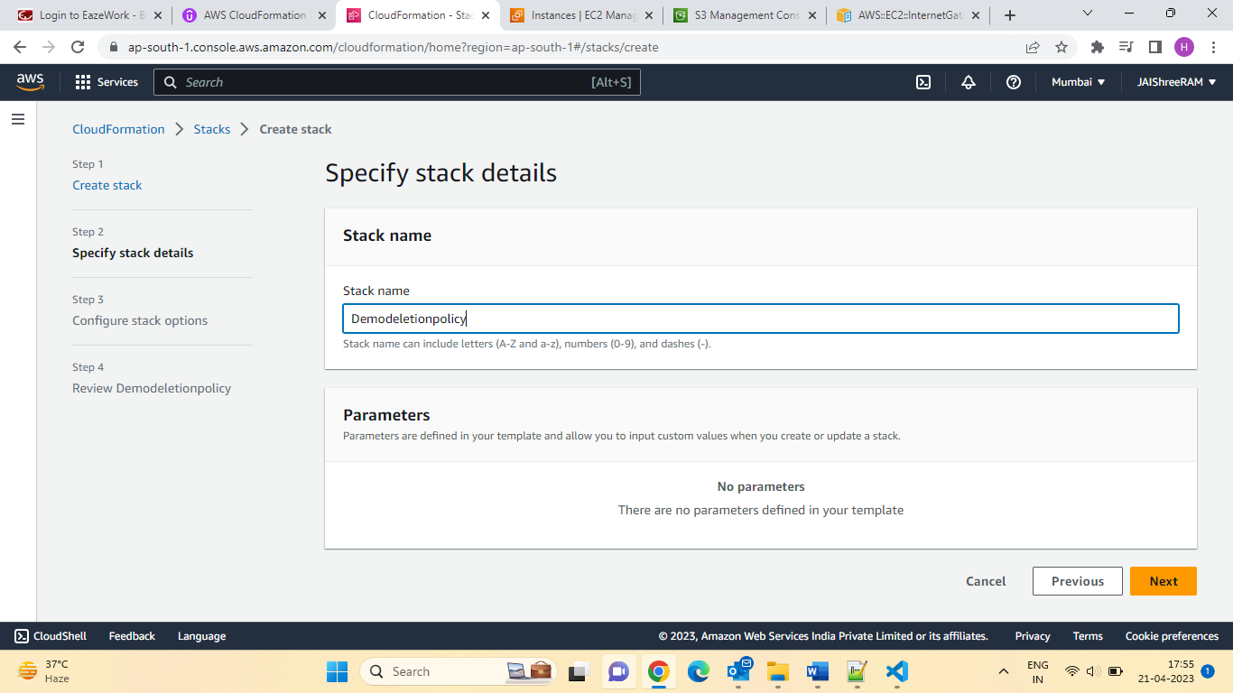

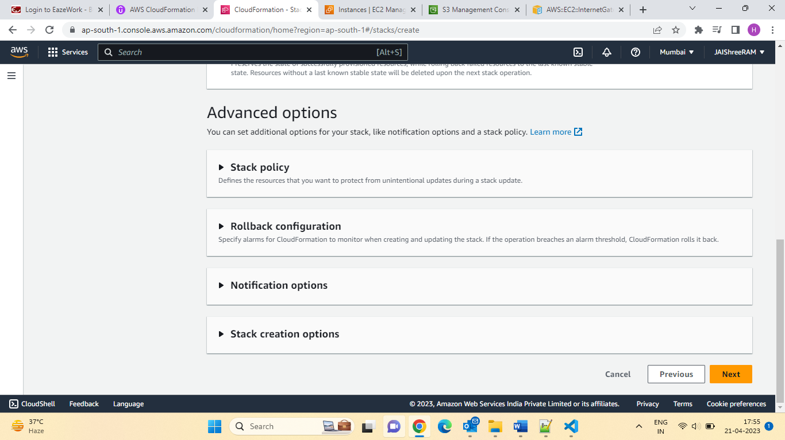

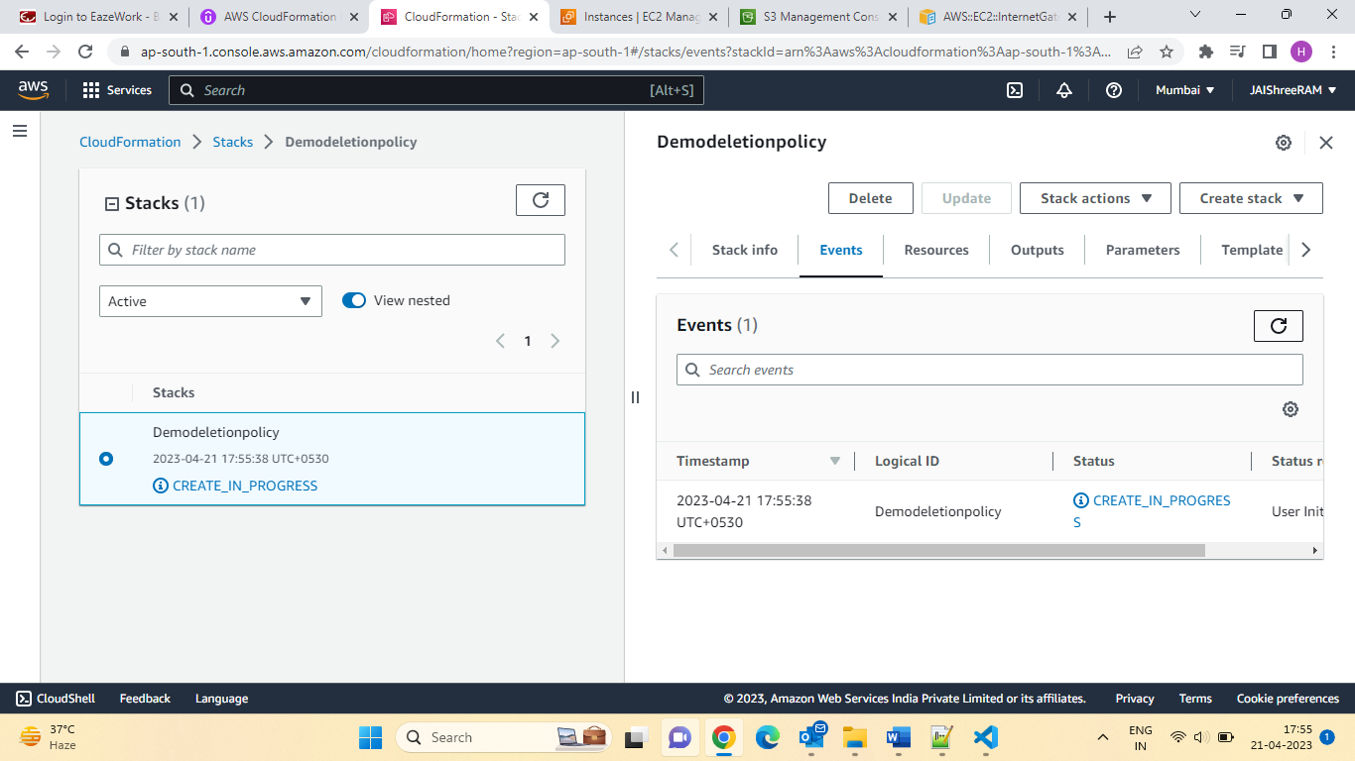

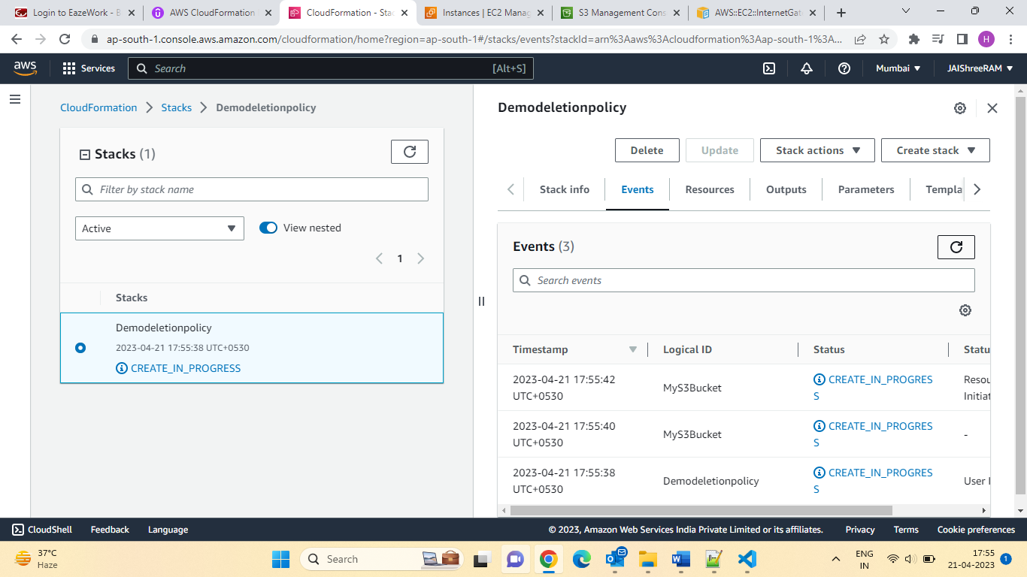

Let upload some file :

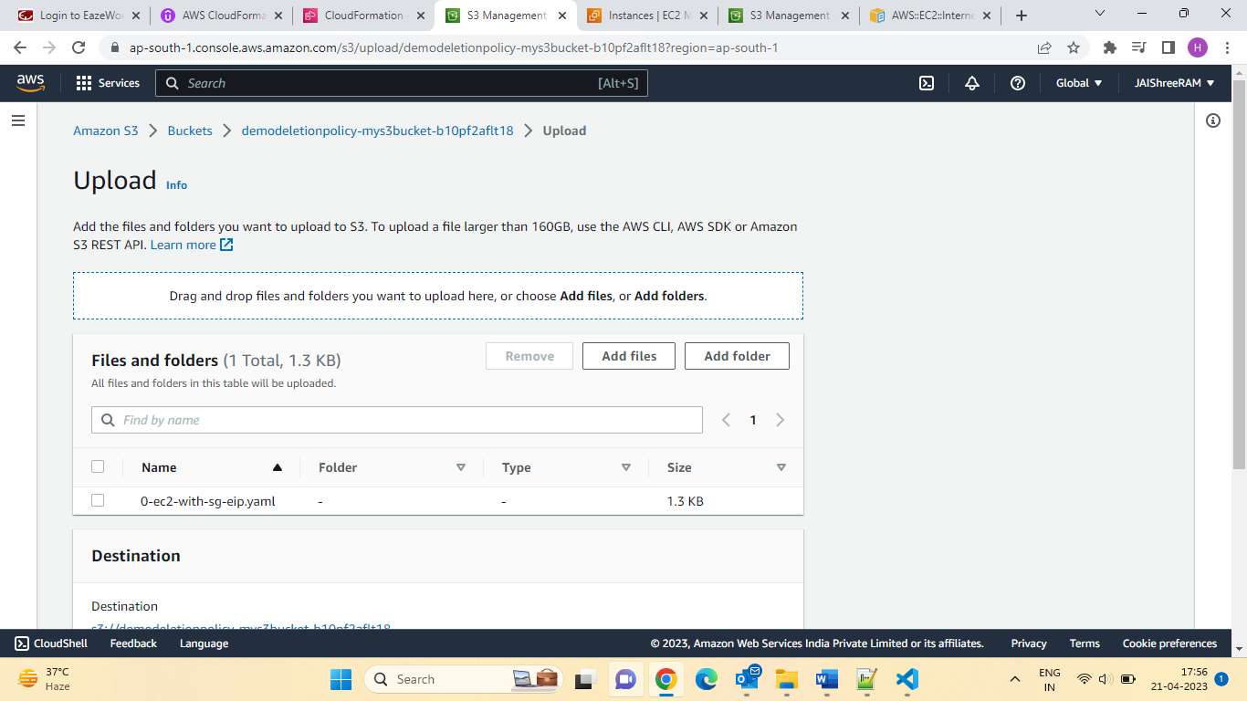

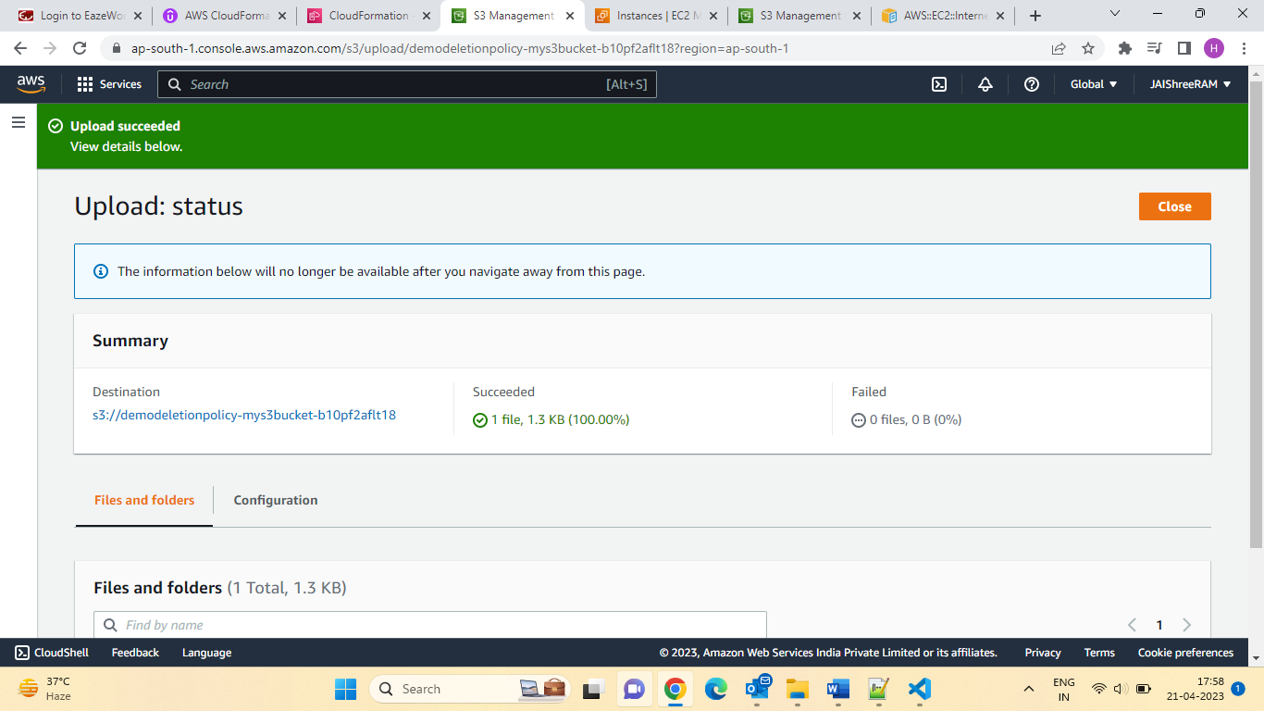

Let try to delete Stack & Check the S3 bucket delete or not.

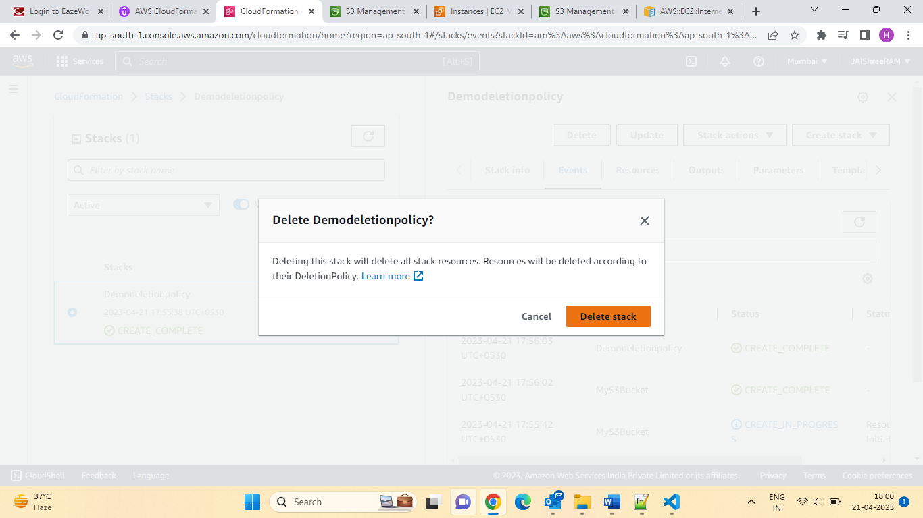

Result: 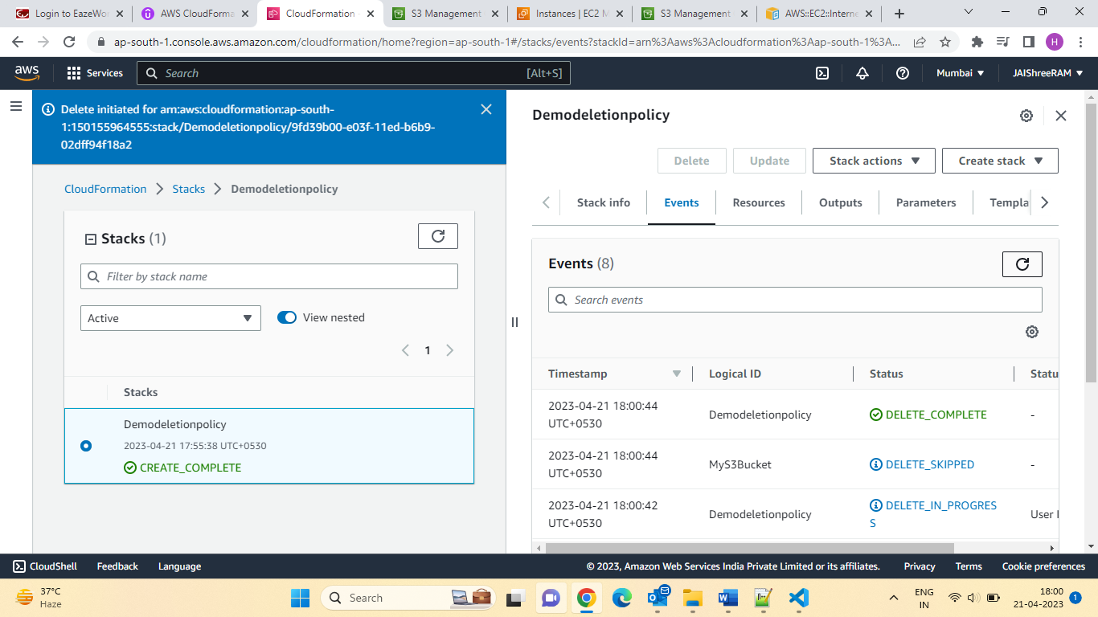

Let check the status for S3 bucket:

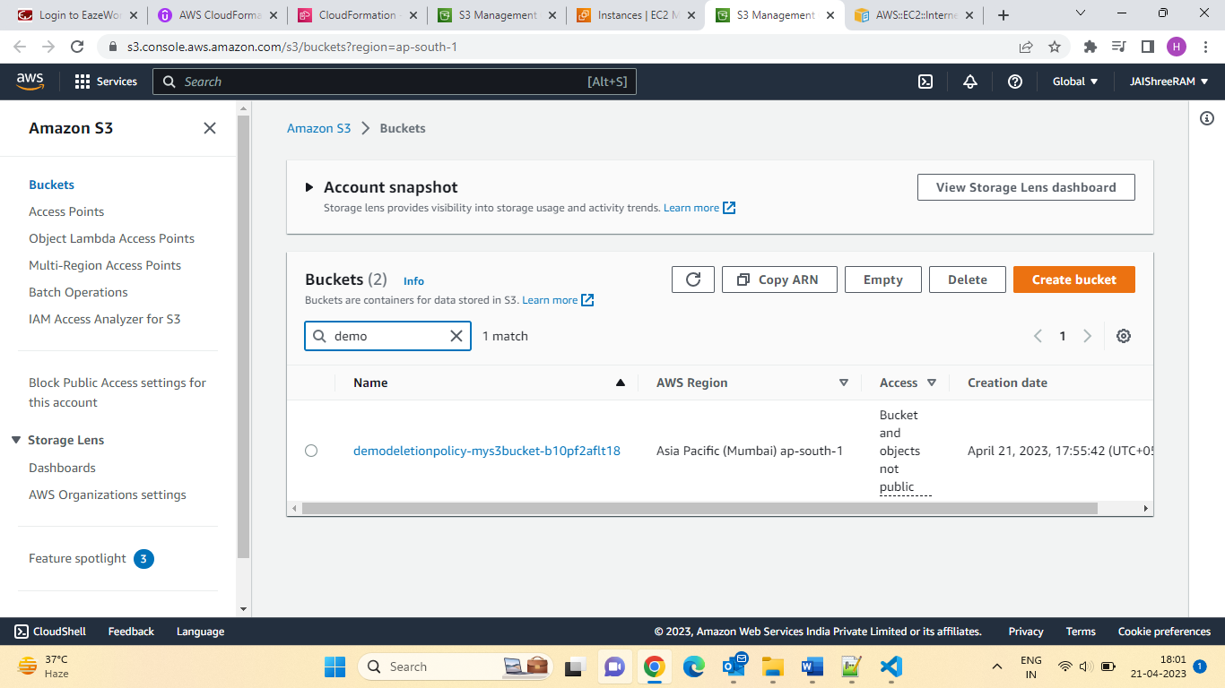

Section 28: Advanced UpdateReplacePolicy:

* Controls what happens to a resource if you update a property whose update behaviour is replacement.
* For example, updating RDS DBInstnace’s Availability Zone Property.
* User with any resource.
* UpdateReplacePolicy=Delete(default behaviour):

24th April 2023:

UpdateReplacePolicy:

* Controls what happens to a resource if you update a property whose update behaviour is replacement.
* For example, updating RDS DBInstnace’s Availability Zone property.
* Use with any resource.
* UpdateReplacePolicy=Delete (Default Behaviour):
* CloudFormation deletes the old resource and creates a new one with a new physical id.
* UpdateReplacePolicy=Retain:
* Keeps the resource (it is removed from CloudFormation’s scope).
* UpdateReplacePolicy=Snapshot:
* EBS Volume, ElastiCache Cluster, ElastiCache, Replication Group
* RDS DB Instance, RDS DB Cluster, RedShift Cluster, Neptune DB Cluster
* The snapshot doesn’t exist in CloudFormation’s scope.

UpdateReplacePolicy Vs Deletion Policy:

**Resources**:

**MyDB:**

   Type:AWS::RDS::DBInstance

    DeletionPolicy: Retain

    UpdateReplacePolicy: Retain

    Properties:{}

* UpdateReplacePolicy only Applies to resource replaced during stack updates.
* Deletion Policy:
* Applies to resource deleted when a stack is deleted.
* Applies when a resource definition delete from the template as part of stack Update.

Let the demo of section 28:

First CreateStack:

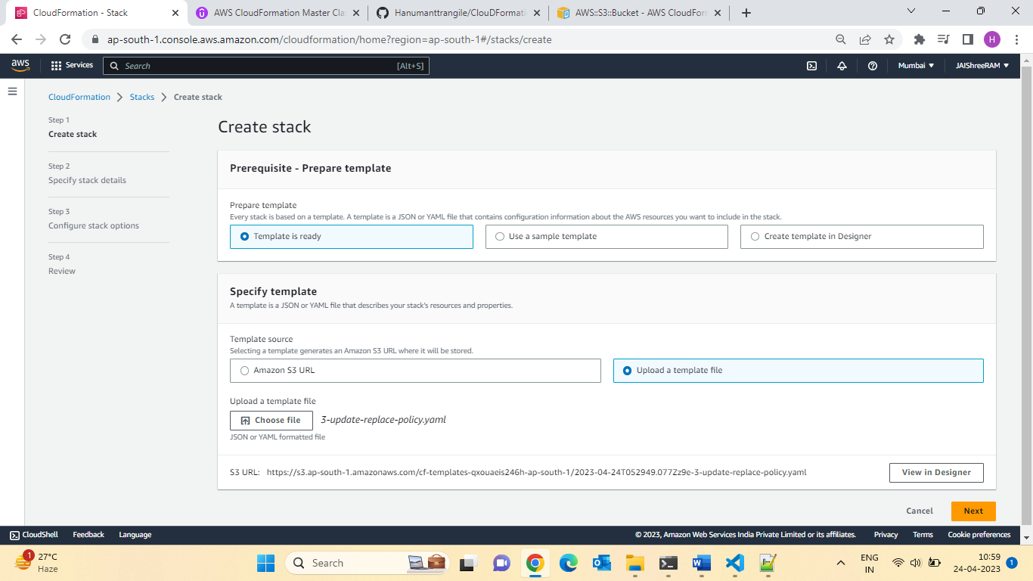

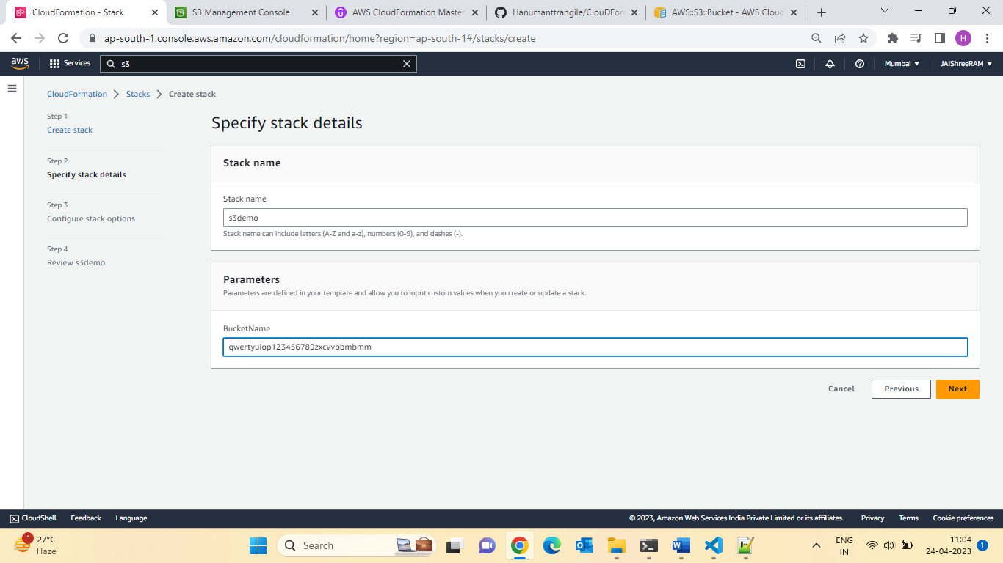

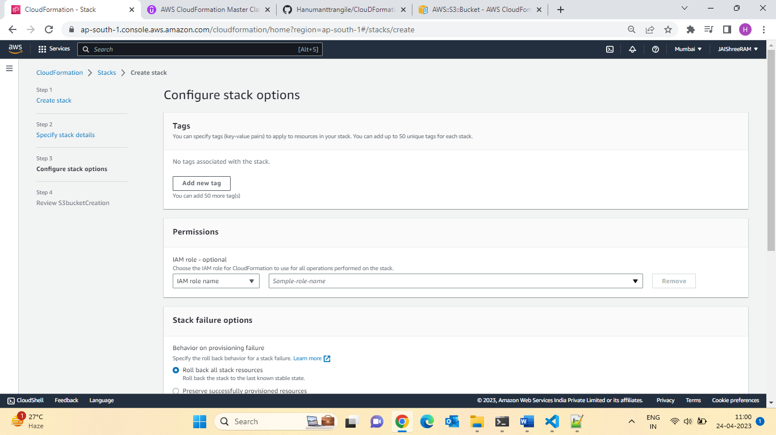

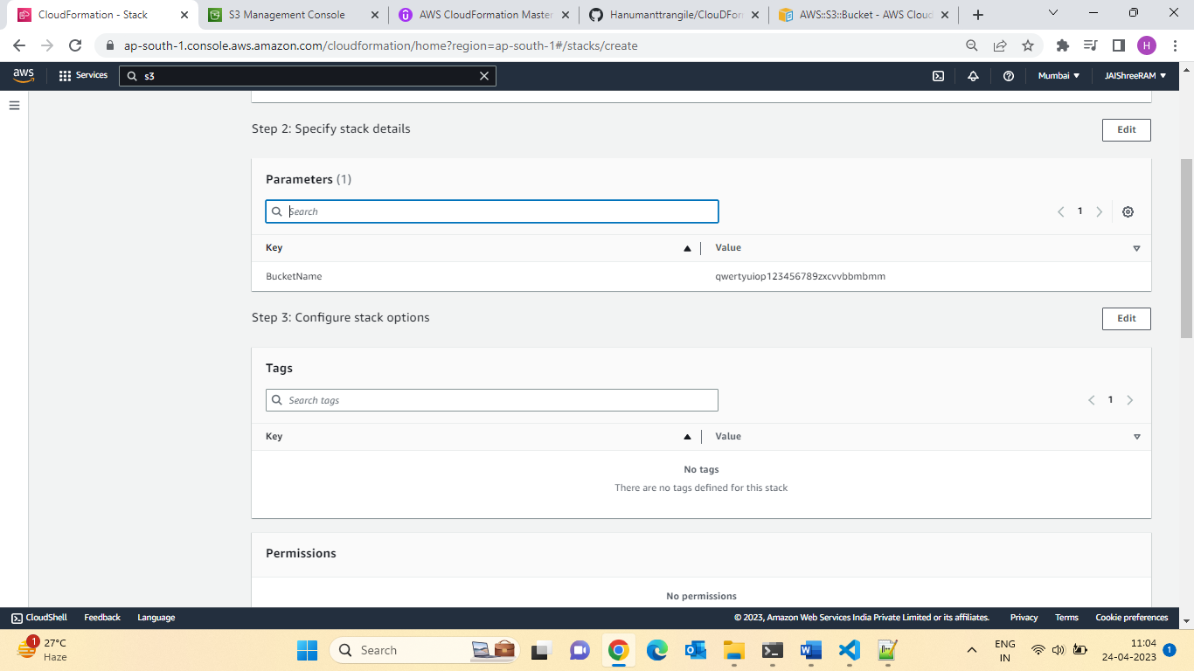

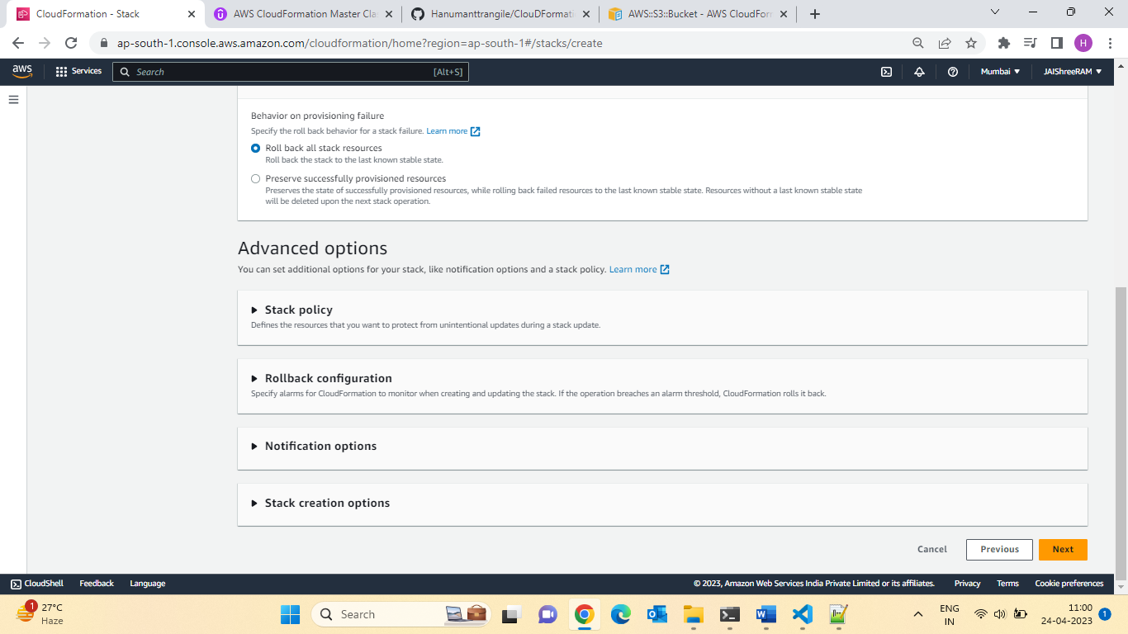

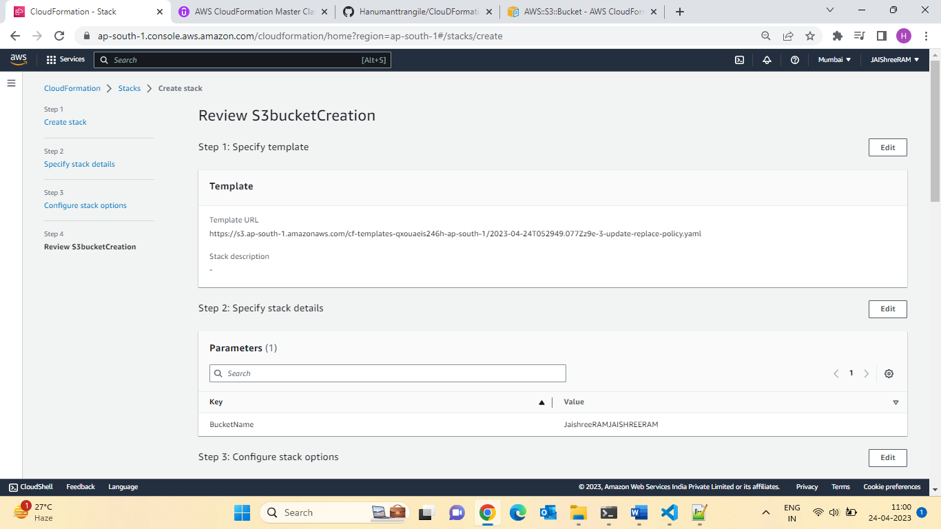

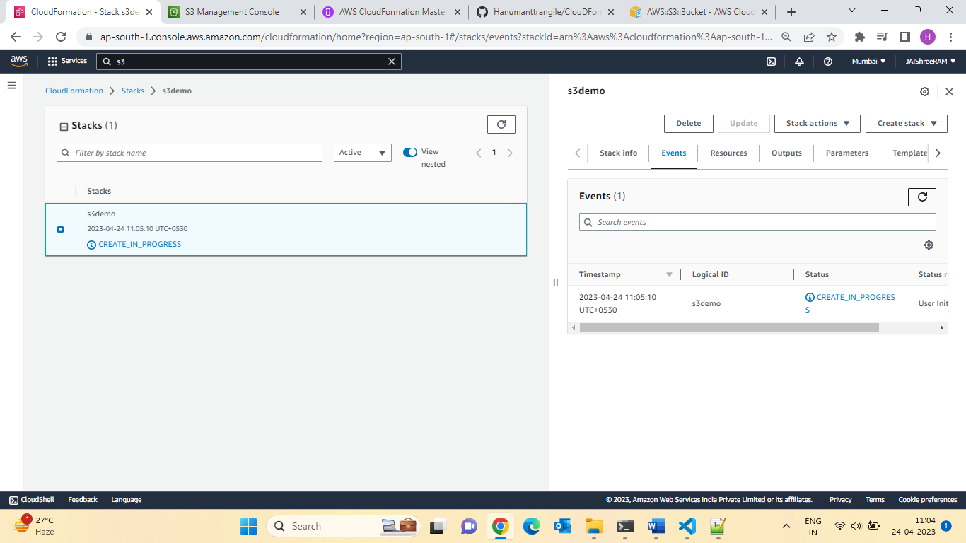

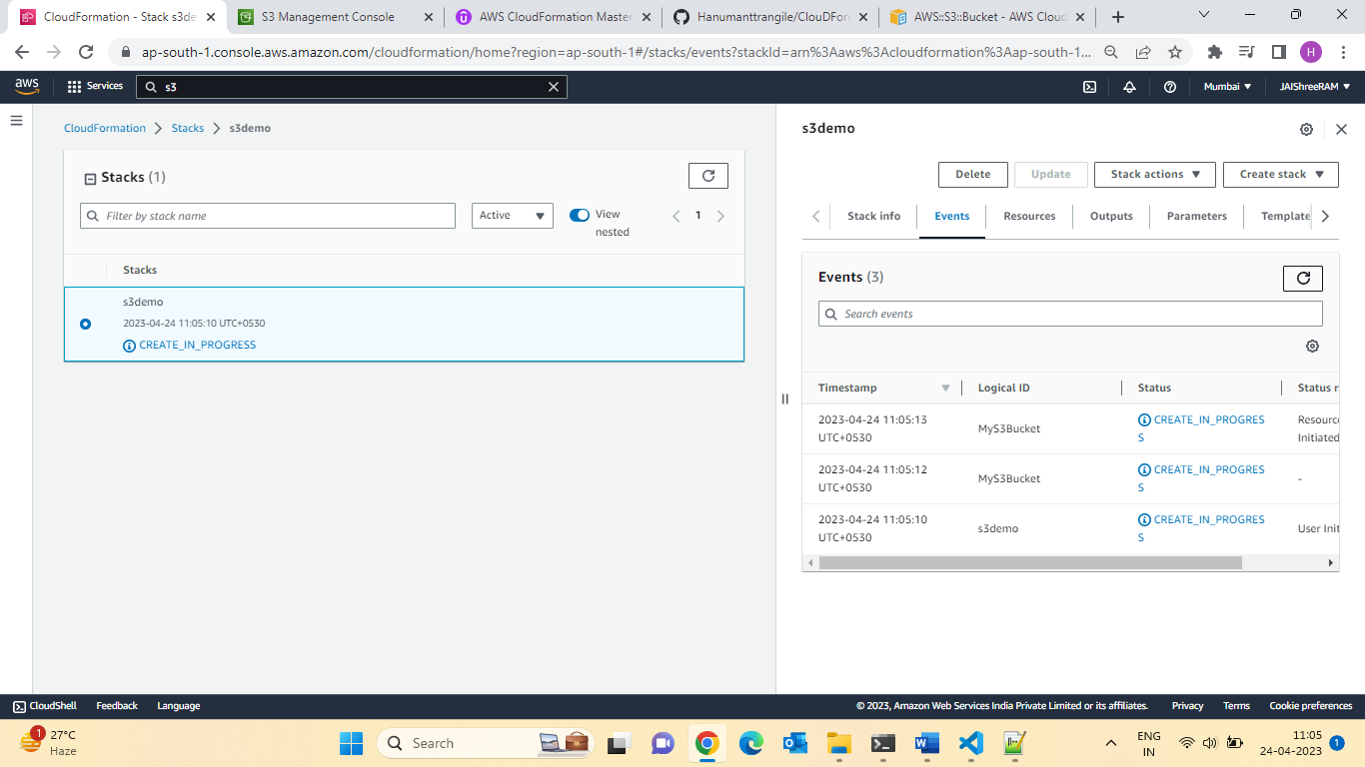

Bucket Status: 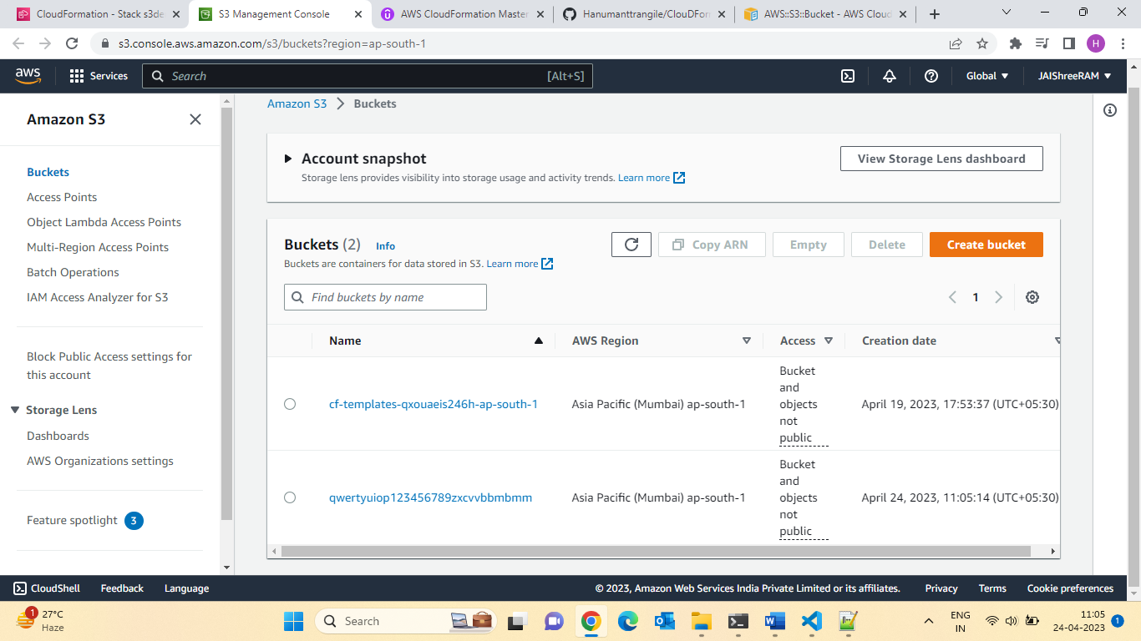

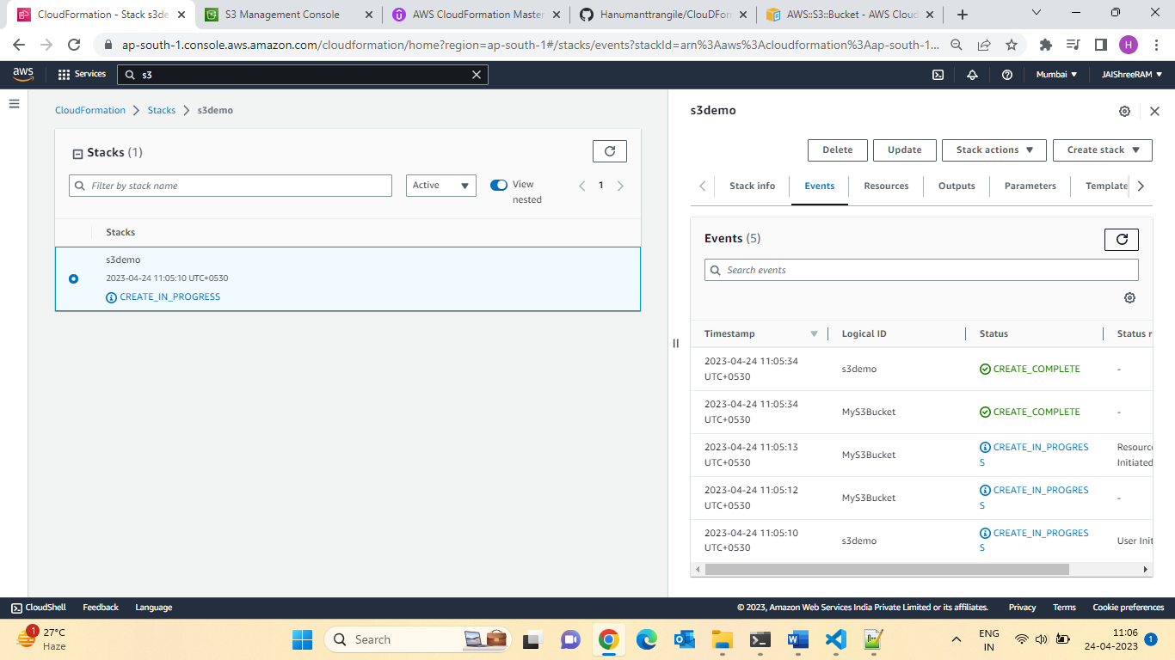

Let update the S3 bucket Name& check behaviour :

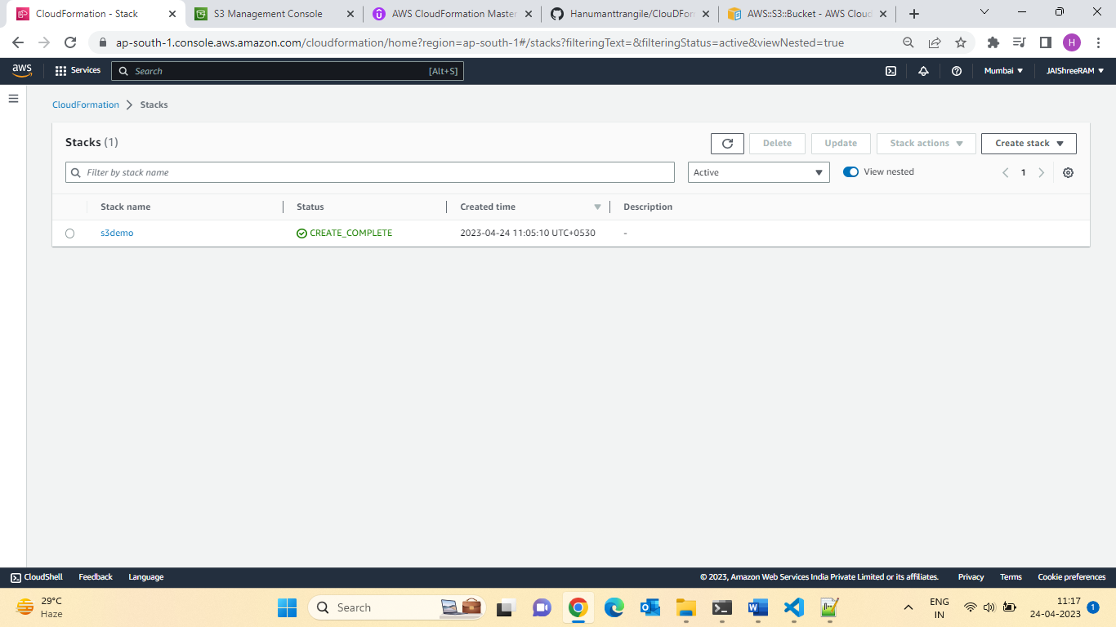

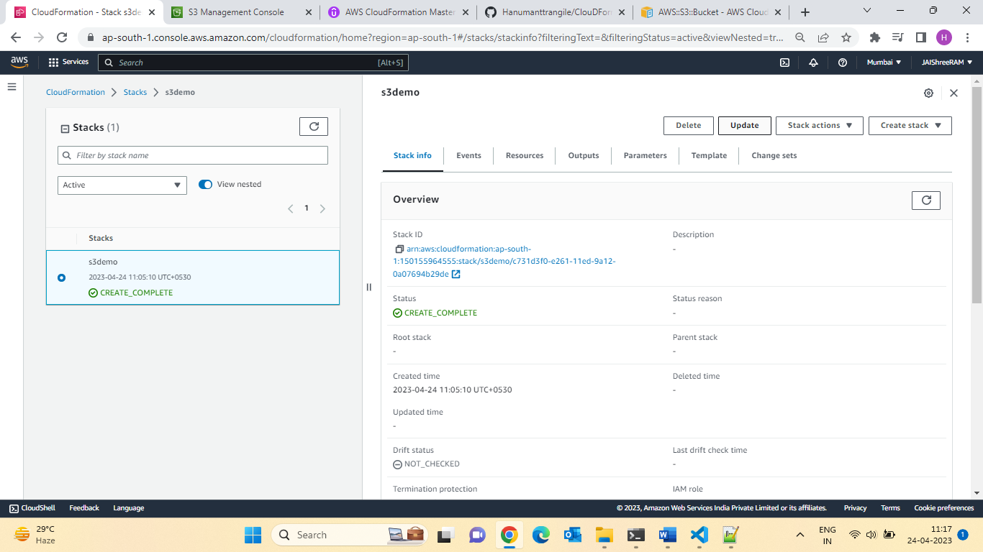

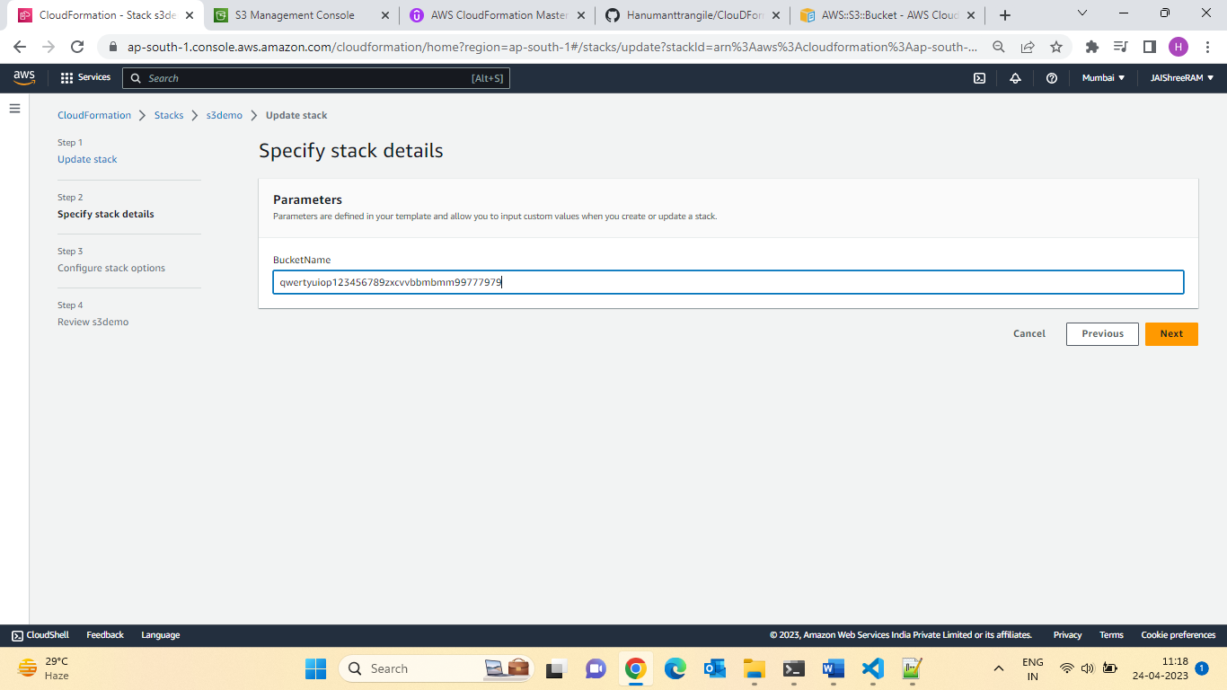

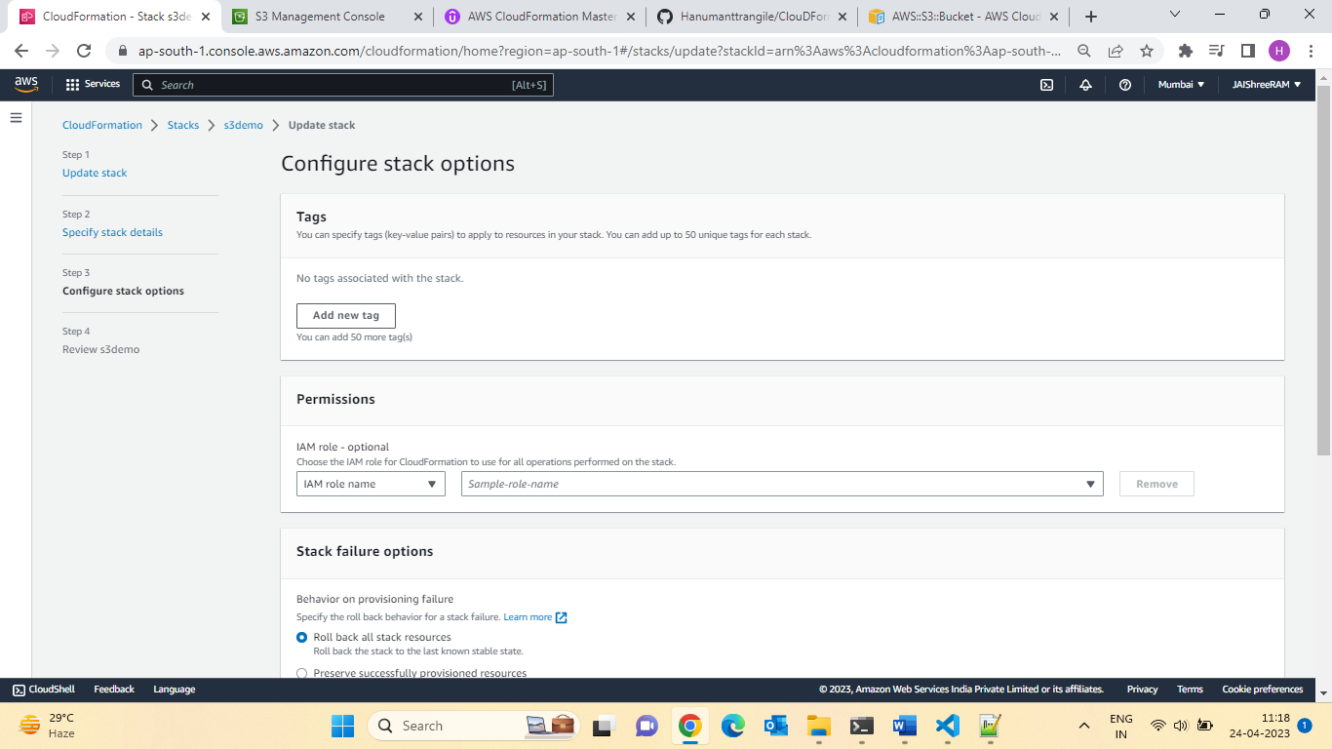

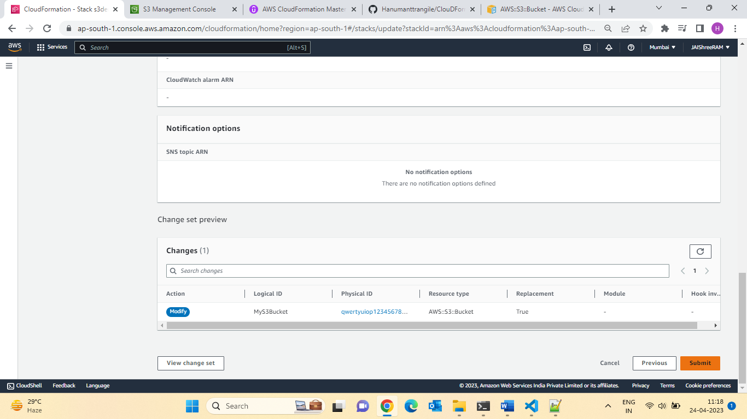

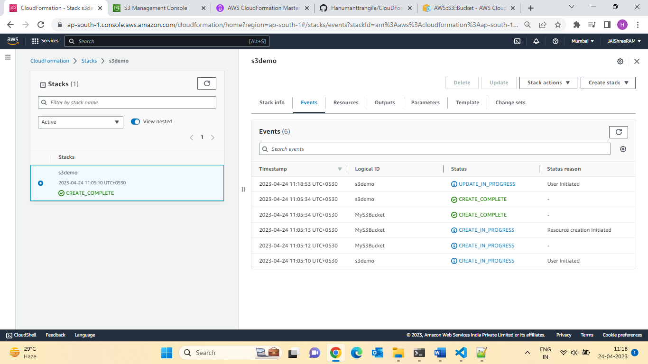

See 3rd Bucket is creating :

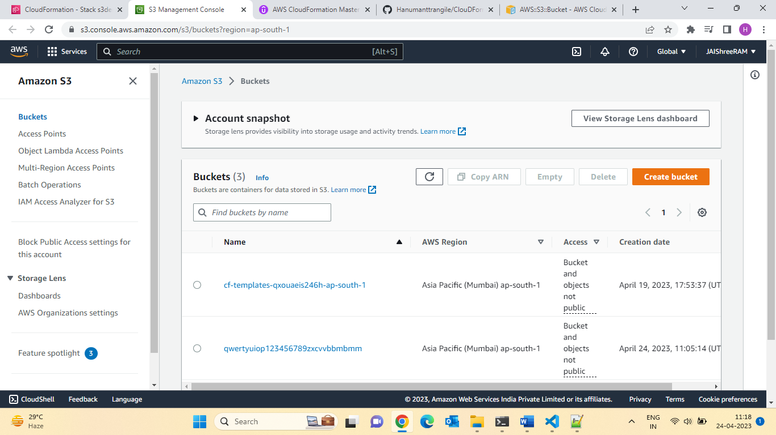

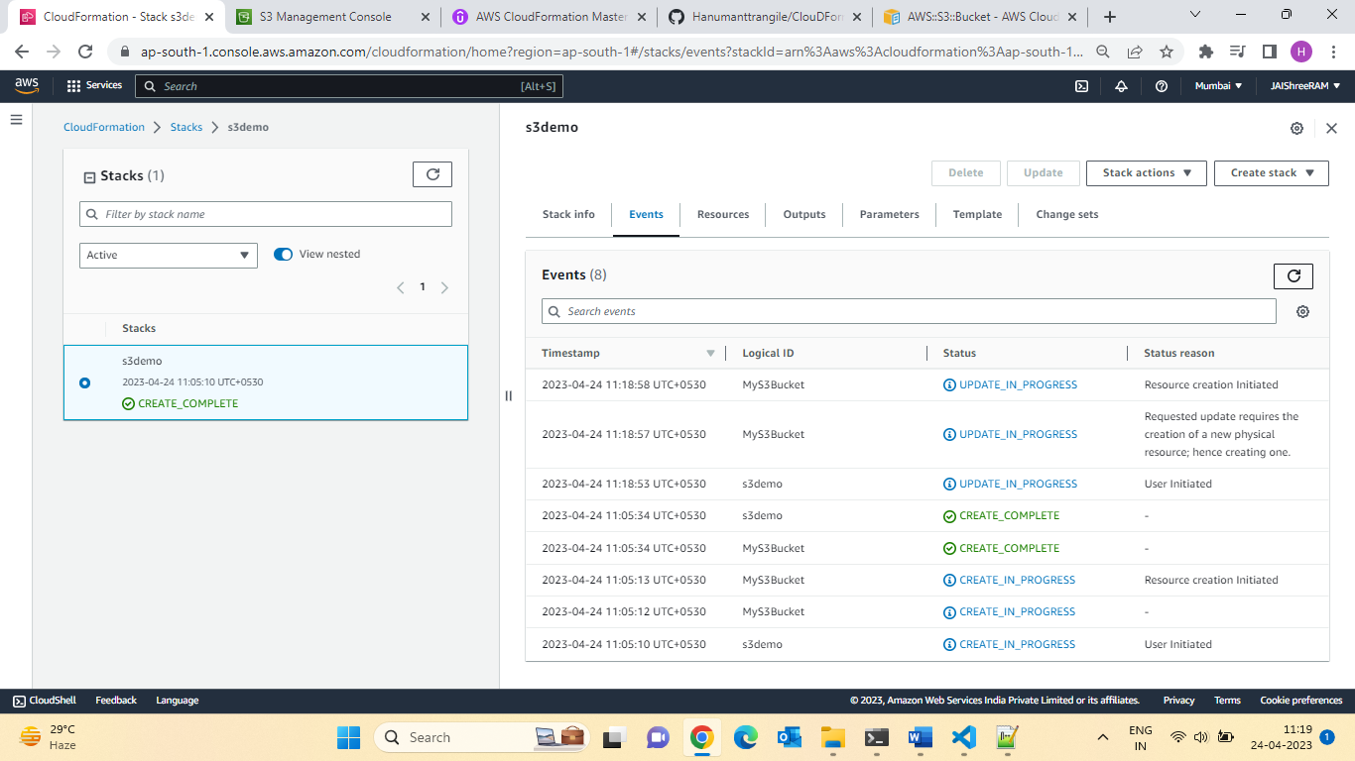

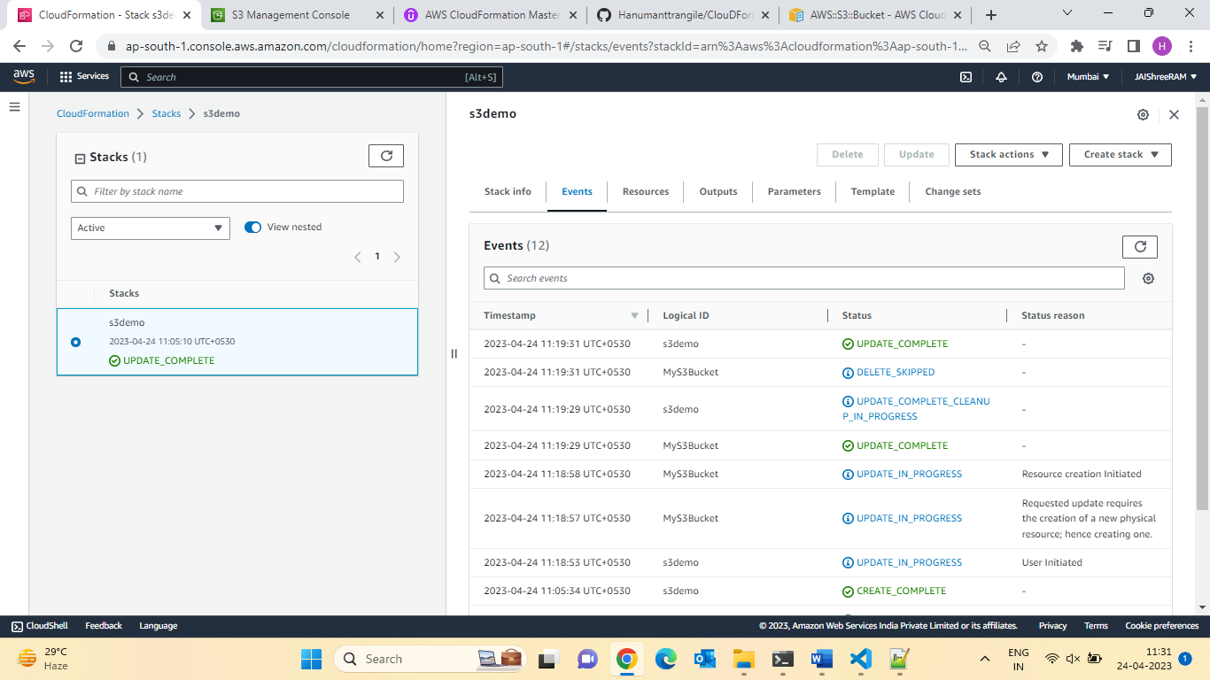

Let delete the stack :

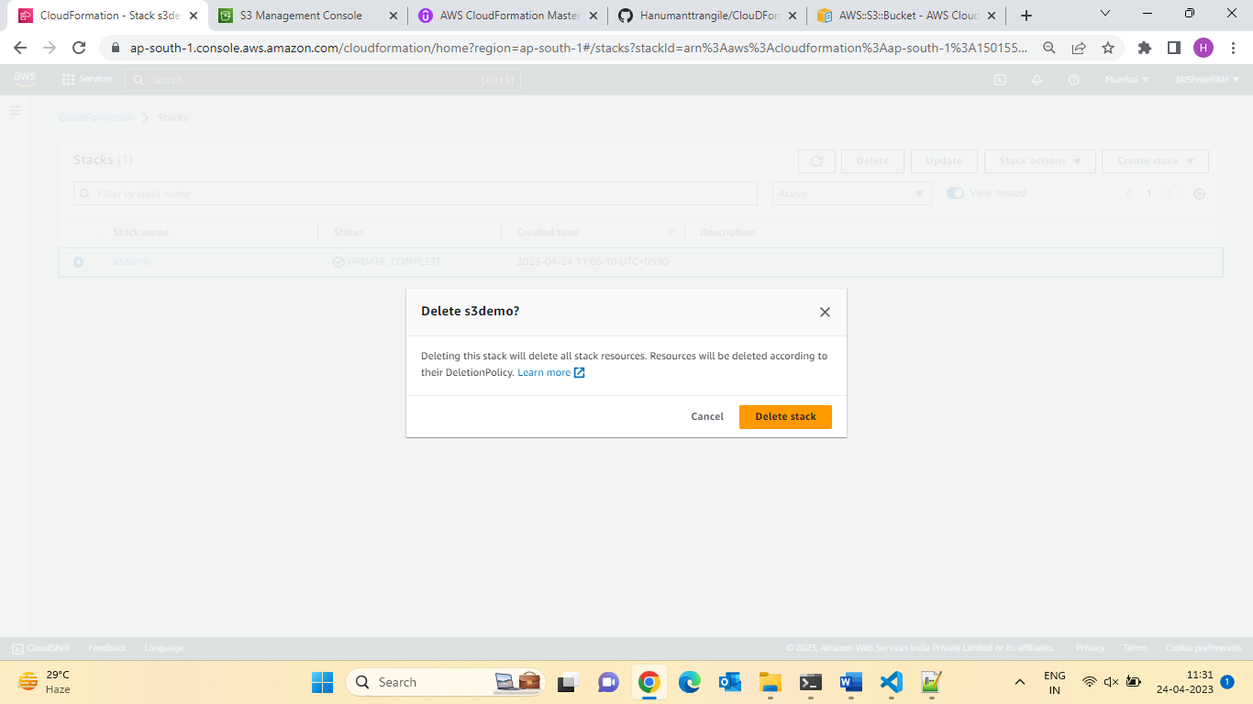

and manual delete the bucket:

FAQ for Resources:

* Can I Create a dynamic number of resources?
* Yes, you can by using CloudFormation Macros & Transform
* Will be discussed later in the course.
* Is every AWS Services supported?
* Almost. Only a select few niches are not there yet.
* You can work around that using CloudFormation Custom Resources.

**Resources Quiz**

Question 1:

In which CloudFormation template section would you write the resources you want to create?

Ans:Resources

Question 2:

You write a CloudFormation template and you want to create an EC2 instance and an RDS database. You want to make sure that the EC2 instance created after the RDS database is created. What attribute would you use?

Ans:Depends on

Q.3: You want to delete a CloudFormation stack that has an S3 bucket that contains documents you want to keep.

Which **DeletionPolicy**value would you use?

Ans:Retain

Section 7: CloudFormation Mappings:

Mappings:

What are mappings?

* Mappings are fixed variables within your CloudFormation template.
* They are very handy to differentiate between different environments(Dev vs Prod), regions(AWS regions),AMI Types etc.
* All the values are hardcoded within the template.
* Example:
* **Mappings**:
* **Mapping01:**
* **Key01:**
* **Name:**  Value01
* **Key02:**
* **Name:**Value02
* **Key03:**
* **Name:**Value03

RegionMap:

  us-east-1:

**HMV64:**ami-0ff8a91507f77f867

**HVMG2:** ami-0a584c55a7631c0c

us-west-1:

HMV64: ami-0ff8a91507f77f867

**HVMG2:** ami-0a584c55a7631c0c

  eu-west-1:

**HMV64:**ami-0ff8a91507f77f867

**HVMG2:** ami-0a584c55a7631c0c

When would you use Mappings VS Parameters?

* Mapping is great when you know in advance all the values that can be Taken and that they can be deduced from variables such as
* Region
* Availability Zone
* AWS Account
* Environment (Dev vs Prod)
* Etc.
* They allow safer control over the template.
* Use parameters when the value are really user specific.

31.Fn: FindInMAP (accessing Mapping Values)

Accessing Mapping Values

* We user Fn::FindInMAP to return a named value from a specific key.
* !FindInMAP [MapName ,TopLevelKey, SecondLevelKey]

**Parameters**:

**EnvironmentName:**

    Description: Environment Name

    Type: String

    AllowedValues: [development, production]

    ConstraintDescription: must be development or production

**Mappings**:

**AWSRegionArch2AMI:**

    af-south-1:

      HVM64: ami-06db08e8636583118

    ap-east-1:

      HVM64: ami-0921e2da2f22f9617

    ap-northeast-1:

      HVM64: ami-06098fd00463352b6

    ap-northeast-2:

      HVM64: ami-07464b2b9929898f8

    ap-northeast-3:

      HVM64: ami-0b96303a469fa0678

    ap-south-1:

      HVM64: ami-0bcf5425cdc1d8a85

    ap-southeast-1:

      HVM64: ami-03ca998611da0fe12

    ap-southeast-2:

      HVM64: ami-06202e06492f46177

    ca-central-1:

      HVM64: ami-09934b230a2c41883

    eu-central-1:

      HVM64: ami-0db9040eb3ab74509

    eu-north-1:

      HVM64: ami-02baf2b4223a343e8

    eu-south-1:

      HVM64: ami-081e7f992eee19465

    eu-west-1:

      HVM64: ami-0ffea00000f287d30

    eu-west-2:

      HVM64: ami-0fbec3e0504ee1970

    eu-west-3:

      HVM64: ami-00dd995cb6f0a5219

    me-south-1:

      HVM64: ami-0502022ce8bfa56a9

    sa-east-1:

      HVM64: ami-0c27c96aaa148ba6d

    us-east-1:

      HVM64: ami-0742b4e673072066f

    us-east-2:

      HVM64: ami-05d72852800cbf29e

    us-west-1:

      HVM64: ami-0577b787189839998

    us-west-2:

      HVM64: ami-0518bb0e75d3619ca

**EnvironmentToInstanceType:**

    development:

      instanceType: t2.micro

    # we want a bigger instance type in production

    production:

      instanceType: t2.small

**Resources**:

**EC2Instance:**

    Type: AWS::EC2::Instance

    Properties:

      InstanceType: !FindInMap [EnvironmentToInstanceType, !Ref 'EnvironmentName', instanceType]

      # Note we use the pseudo parameter AWS::Region

      ImageId: !FindInMap [AWSRegionArch2AMI, !Ref 'AWS::Region', HVM64]

Section 32: Hands-on

* Let’s use this mapping and see how we can combine it with a parameter in order to deduce values.
* We will change the instance type of Our ECE instance based on the environment we are in.
* We will change the AMI of our EC2 instance based on the AWS Region we are in

Let do the demo:

Let create the Stack:

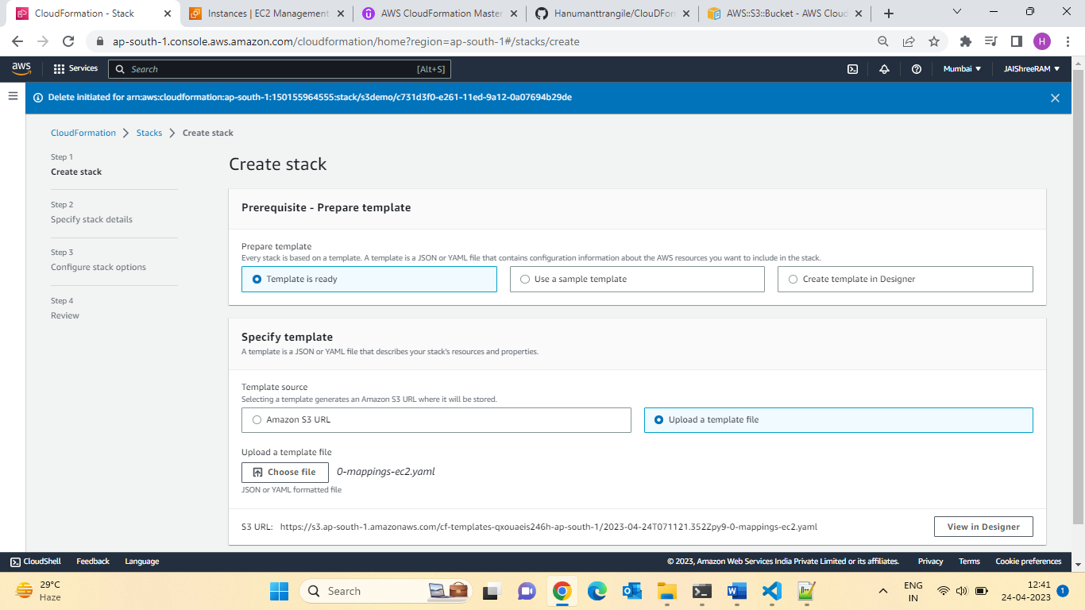

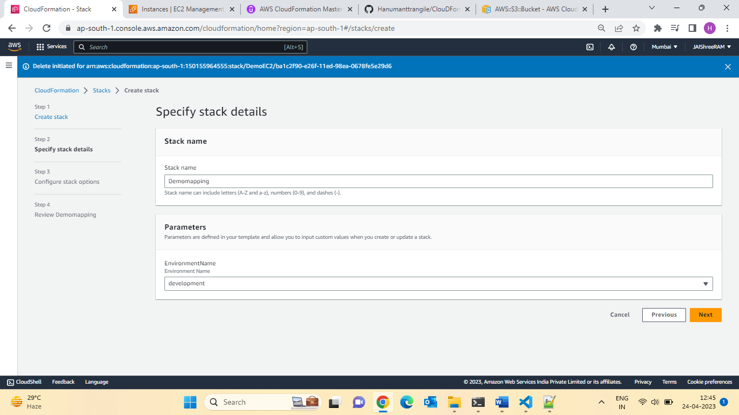

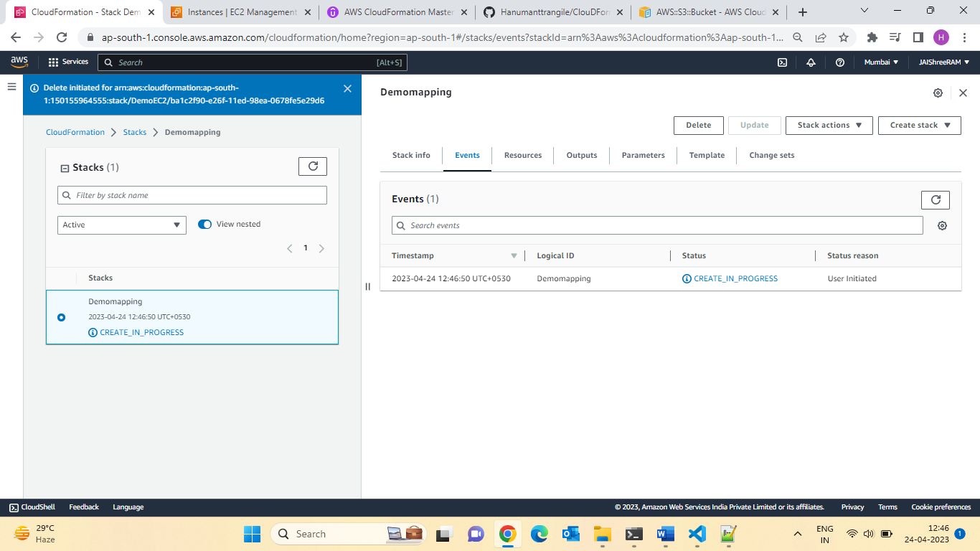

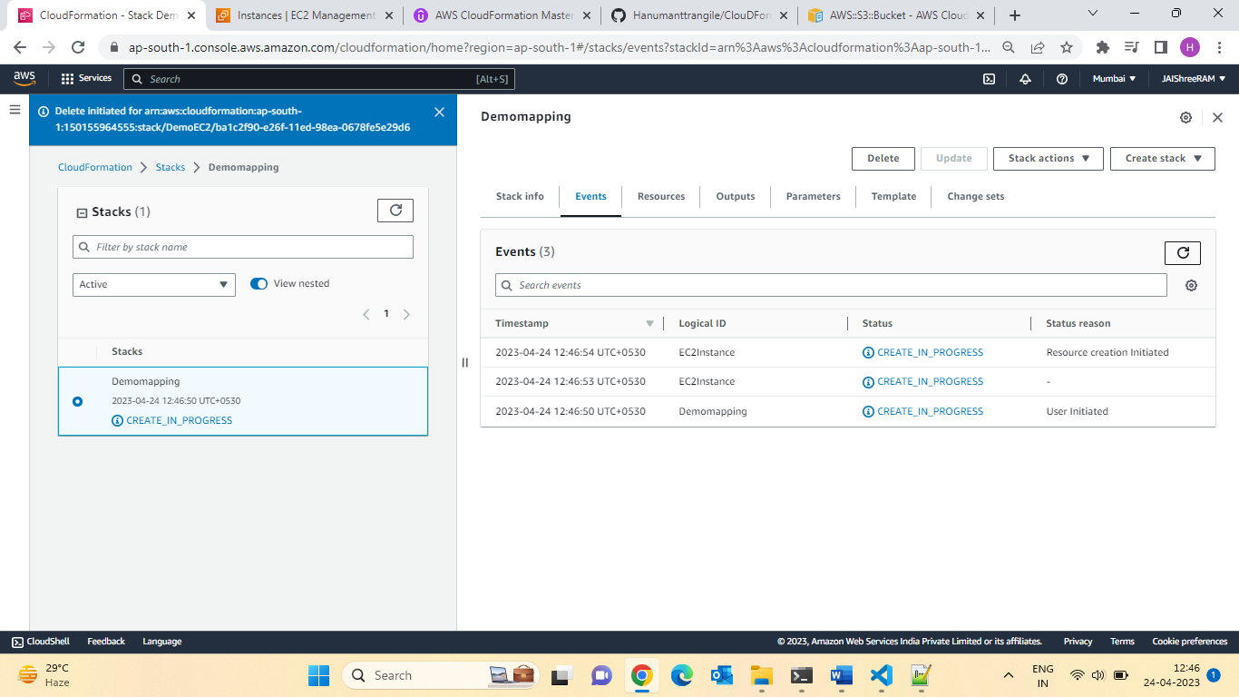

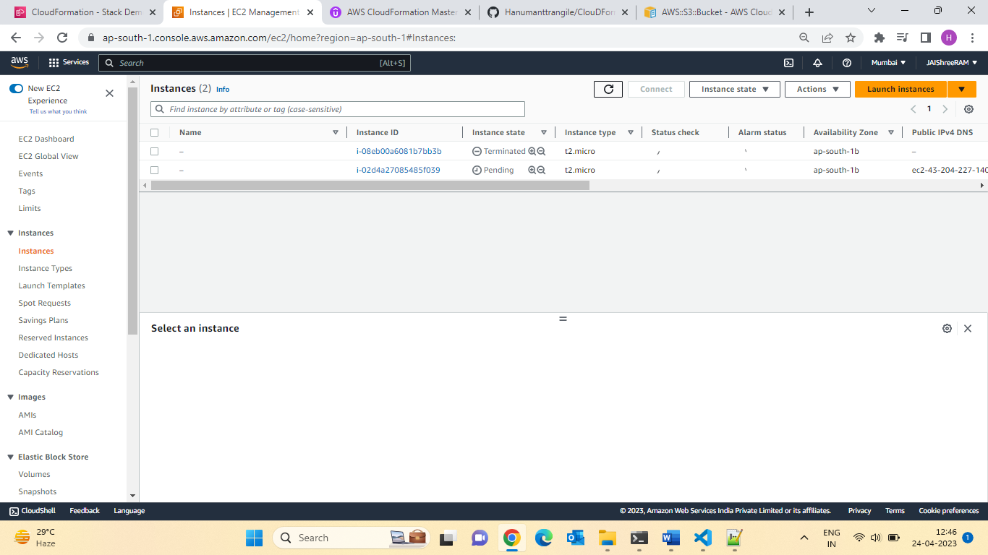

Let assign the Key pair to EC2:

